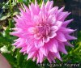 | 18TH SURGICAL HOSPITAL B SC V LV/PR |  | 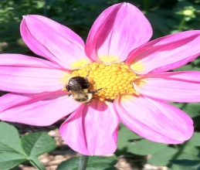 | 2010 SEEDLING PK |  | 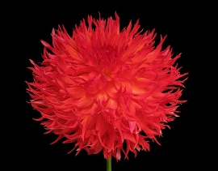 | AJA  B LC  FL
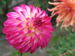 | AC AQUARIUS  ST DB DR/WH |  | 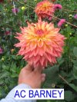 | AC BARNEY B SC DB O Y |  | 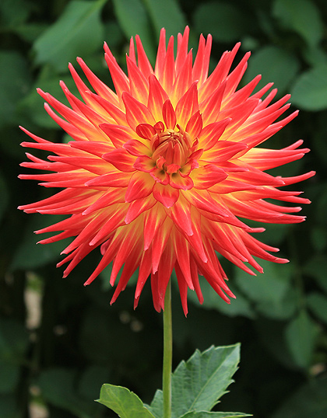 | AC ABBY B C FL RD/YL
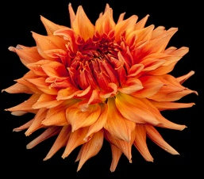 | AC BEN AA SC LB OR/YL |  | 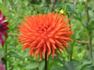 | AC CJ BB SC OR |  | 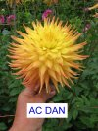 | AC DAN A SC LB YL/PK
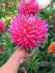 | AC DARKHORSE AA SC PR |  | 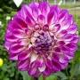 | AC DEVIN BB FD DB PR/WH |  |  | AC FANCY BB FD BI RD/WH
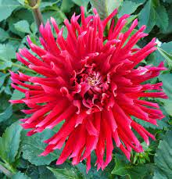 | AC JOE B IC DR |  | 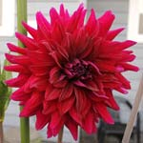 | AC KAHUNA A ID PR |  | 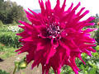 | AC LOOMIS A ID PR
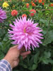 | AC L B SC L |  | 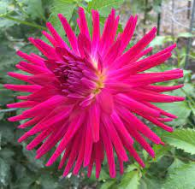 | AC MP G-1 BB C PR |  | 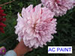 | AC PAINT A ID V WH/DR
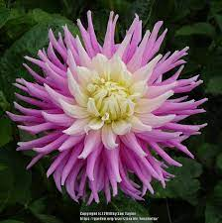 | AC PETALICIOUS BB IC LB LV/WH |  | 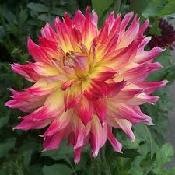 | AC RING OF FIRE A ID DB R/Y |  | 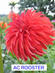 | AC ROOSTER  ST R
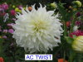 | AC TWIST A ID W |  | 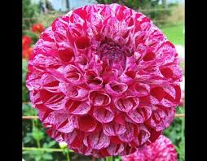 | AC WHITE RABBIT BA V DR/WH |  | 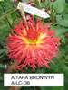 | AITARA BRONWYN A LC DB
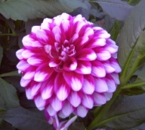 | AITARA DIADEM  BB FD BI DP/W |  | 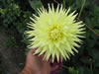 | AITARA MAJESTY A SC Y |  | 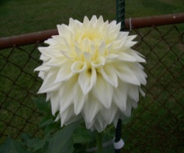 | ALLIE WHITE BB ID W
 | AKITA  NX DR |  | 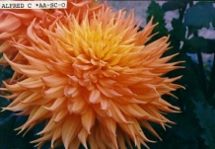 | ALFRED C.  AA SC O |  | 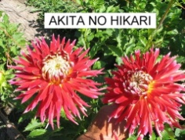 | AKITA NO HIKARI  NX DR

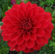 | ALI OOP BB ID R |  | 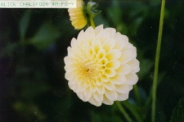 |  | ALICE CHALIFOX  M FD Y |  | 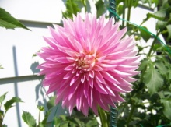 | ALLOWAY  CANDY  ST PK
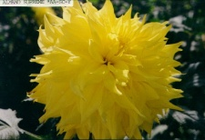 | ALMAND SUPREME  AA SC Y |  | 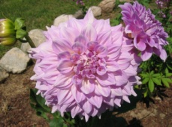 |  | ALMAND JOY  A FD L/W |  |  | ALPEN BILL B SC LB W/L
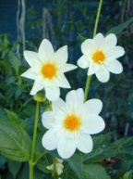 | ALPEN CHERUB  CO W |  | 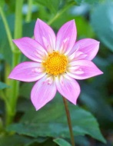 |  | ALPEN DIAMOND  CO LB L/W/wh |  | 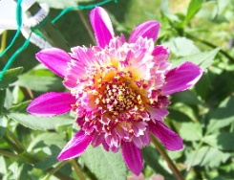 | ALPEN PEARL  AN L lb/w/y
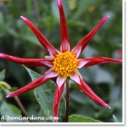 | ALPEN SAMI  O DR DR/lb/w/r |  | 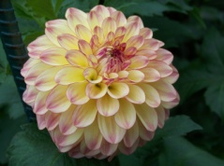 |  | ALPEN SUNDOWN BB FD DB PR/Y |  | 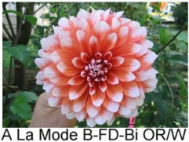 | A LA MODE B FD BI BR/WH
 |  |  |  | ALEX S B ID DB |  |  | 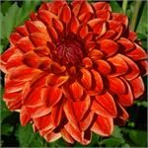 |  | ALL THAT JAZZ BB FD DB RD/YL
 |  | 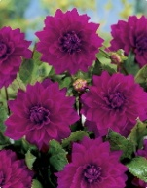 |  | ALVA’S REGALIA  AA FD PR |  |  | 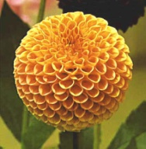 |  | AMBERGLOW  MB
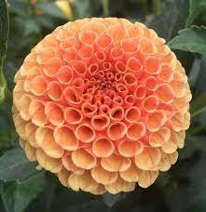 | AMBER QUEEN P BR |  |  |  |  |  | 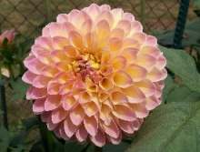 |  | AMGARD CORONET  M FD PK
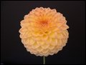 | AMBER FESTIVAL  BB FD LB | 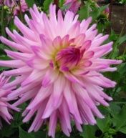 |  | AMY K  B SC LB PK/W |  |  |  |  | AMORUS M FD V OR/R
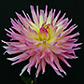 | ANDREW DAVID A IC LB PK/Y | 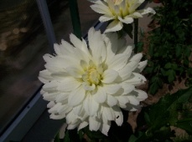 |  | ANGEL’S DUST  WL WH |  |  | 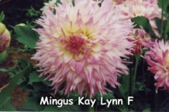 | ANNA MARI LC W/PR

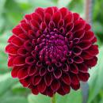 | ANN MARIE  M FD DR |  | 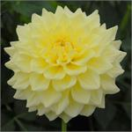 | A PEELING B FD Y
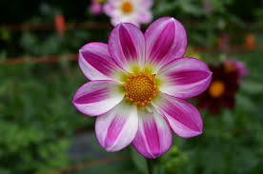 | APOPA SKY S DB DP/WH |  | c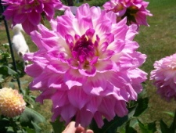 | APRIL DAWN B ID LB WH/PK |  | 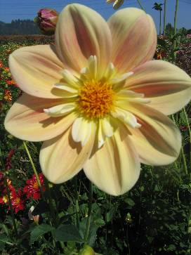 | APRIL HEATHER CO LB PK/Y bi W/Y
 |  |  | 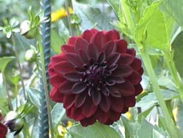 | ARABIAN KNIGHT M FD DR |  | 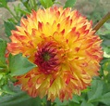 | ARENA’S SUNSET M LC FL RD/YL
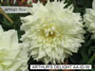 | AUTHER’S DELIGHT  AA-ID-W |  | 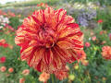 | AUTUMN’S GIFT BB FD V O/RD |  | 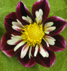 | AWAIKOO COL MAR/WH
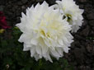 | AYER’S MABEL II  A ID W |  | 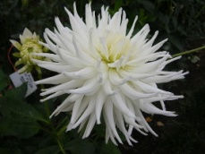 | AYER’S WHITE KNIGHT  AA SC W |  | 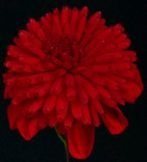 | AZUMA KAGAMI  AN DR
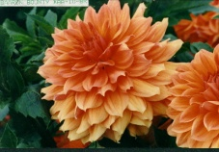 | BAARN BOUNTY  AA ID BR |  |  | BABETTE  BA LPK |  | 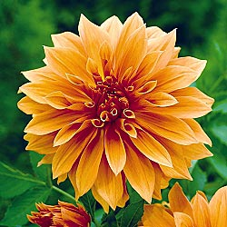 | BABYLON  BRONZE  B FD O
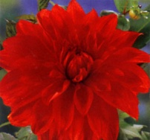 | BABYLON  RED  B FD R |  | 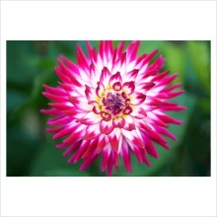 | BADGER TWINKLE  M SC DB PR/W |  | 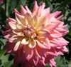 | BAHAMA MAMA BB ID DB YL PR
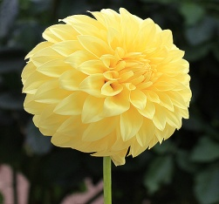 | BARBARA BLOOMQUIST BB FD Y |  | 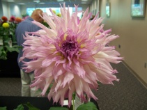 | BARBARA HARDISTY KANTOR  AA LC LB W/PR |  | 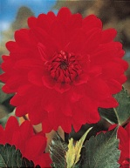 | BARBAROSA  B FD R
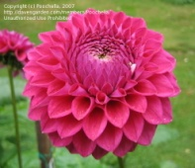 | BARBARRY FUSILIER  BB FD PR |  | 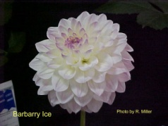 | BARBARRY ICE  BB FD LB W/R |  | 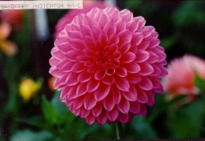 | BARBARRY INDICATOR  B L
 |  |  | 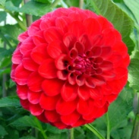 | BARBERRY INTREPID  BB FD R |  | 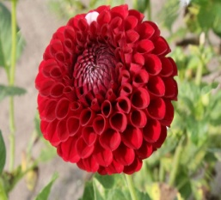 | BARBARRY MAVERICK BA DR
 |  |  | 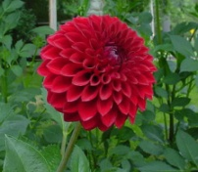 | BARBARY RED BARON  M FD DR |  | 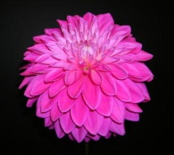 | BARGALY BLUSH  B FD DP
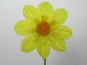 | BARON AUNT DOROTHY CO Y |  | 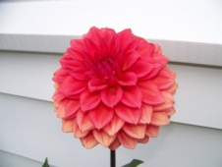 | BARON CHAD B FD BR |  | 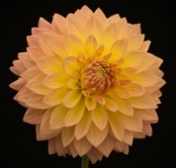 | BARON JERRY BB FD LB Y/PK
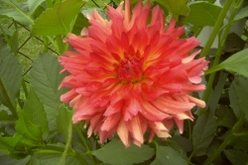 | BARON KATIE  BB ID FL |  | 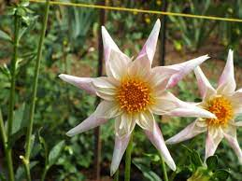 | BARON NIKKI OT DB WH DP |  | 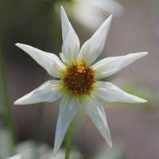 | BARON SYLVIA OT WH
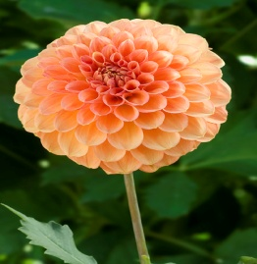 | BARON TODD BB FD OR |  | 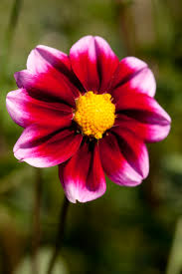 | BASHFUL  S BI PR/L |  | 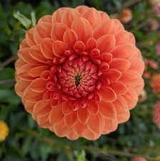 | BEATRICE MB OR

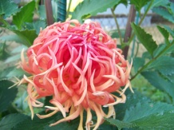 | BEDHEAD  BB IC O |  | 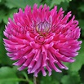 | BEEP BEEP B IC PR |  | 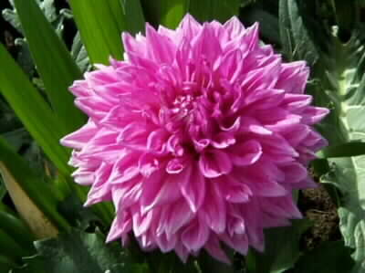 | BELLA S.  AA ID L
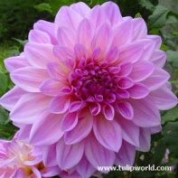 | BELLE OF BARMERA  AA ID DP |  | 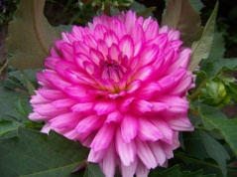 | BELLINI PINK BORDER DAHLIA 15” BB ID PK |  | 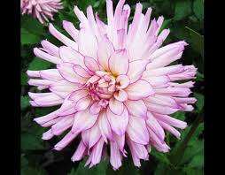 | BELRED DESIRE BB SC LB LV/WH
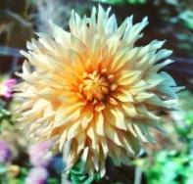 | BENCHMARK  A ID LB  Y/O |  | 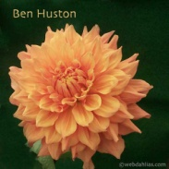 | BEN HUSTON  AA ID BR |  | 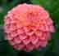 | BERNADETTE CASTRO  M FD DPK
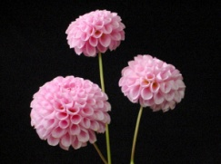 | BETTY ANN  P PK |  | 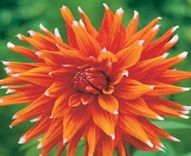 | BI COLOR SPECTACULAR B SC BI O/W |  | 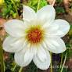 | BETTY’S WHITE COLLARETE  CO W
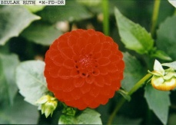 | BEULAH RUTH  M FD DR
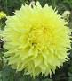 | BIG GUY SLICE BB LC YL |  | 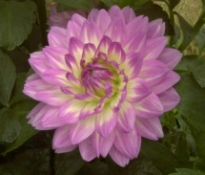 | BITSY  WL PK/W |  | 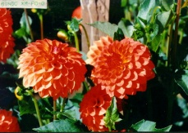 | BINGO  M FD OR
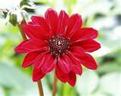 | BISHOP OF  LLANDAFF  PE DR |  | 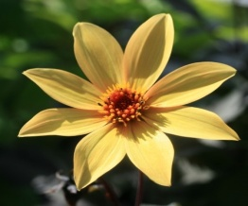 | BISHOP OF YORK S Y |  | 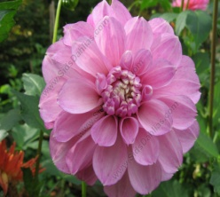 | BLACK BERRY ICE BB FD L/PK
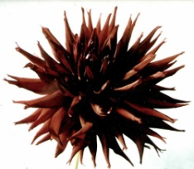 | BLACK  NARCISSUS  B LC DR |  | 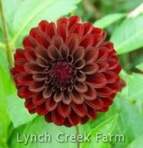 | BLACK SATIN  BB FD DR |  | 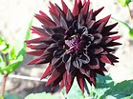 | BLACK WIZARD A C DR
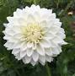 | BLIZZARD M FD W |  | 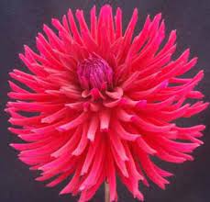 | BLOOMQUIST AMETHYST B IC DR |  | 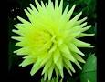 | BLOOMQUIST ANGEL BB SC YL
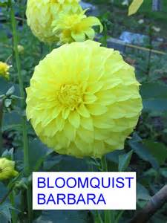 | BLOOMQUIST BARBARA BB FD Y |  | 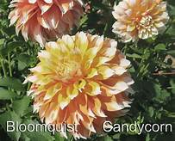 | BLOOMQUIST CANDY CORN BB ID BI OR/WH |  | 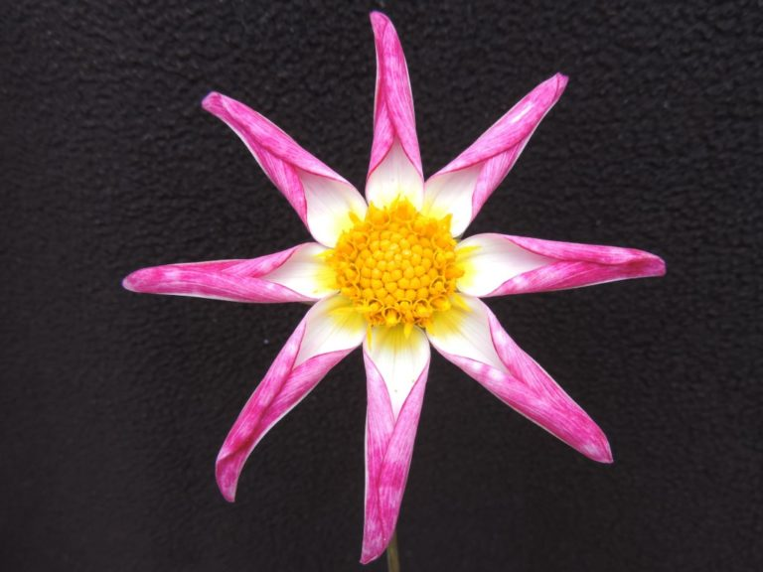 | BLOOMQUIST CATHERINE O DB DP/WH
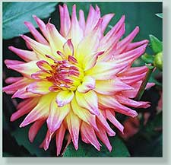 | BLOOMQUIST DAWN  BB SC DB DP/Y |  | 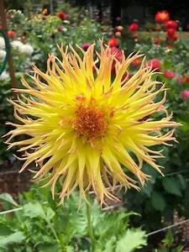 | BLOOMQUIST DANDELION B LC YL/OR |  | 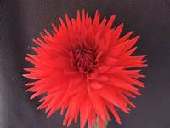 | BLOOMQUIST DON B SC RD
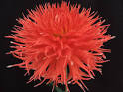 | BLOOMQUIST FLIRT B LC OR |  | 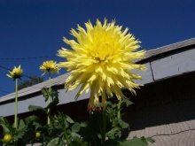 | BLOOMQUIST GLOW  AA LC Y |  | 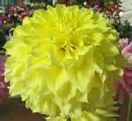 | BLOOMQUIST GOLDILOCKS BB ID Y
 | BLOOMQUIST ISLA P |  | 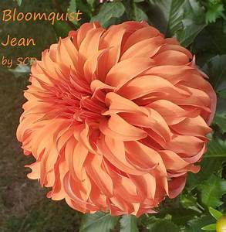 | BLOOMQUIST JEAN B ID OR |  | 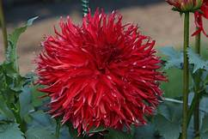 | BLOOMQUIST JOEL B LC RD
 |  |  | 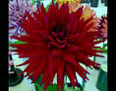 | BLOOMQUIST KAL BB SC PR |  | 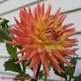 | BLOOMQUIST KAREN G B SC LB BR/YL
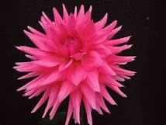 | BLOOMQUIST LAURA B SC L |  | 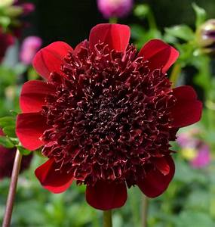 | BLOOMQUIST LARRIE ANN AN PR/dr |  | 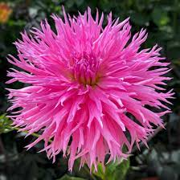 | BLOOMQUIST LOU ANN BB LC L
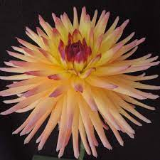 | BLOOMQUIST MARY LOU BB IC LB YL/PK |  | 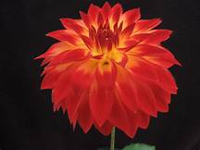 | BLOOMQUIST MICHAEL F P DB DR/YL |  | 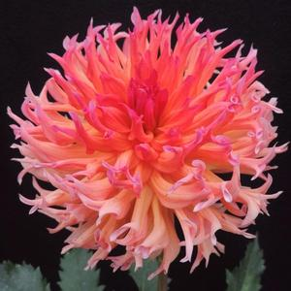 | BLOOMQUIST MIKE BB LC DB DP/OR
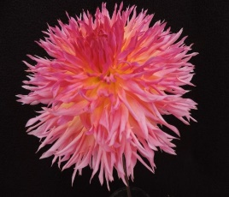 | BLOOMQUIST MILDRED S BB LC LB YL/PK |  | 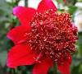 | BLOOMQUIST OBEISANCE AN DR |  | 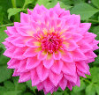 | BLOOMQUIST PARASOL  B ID LB PK.W
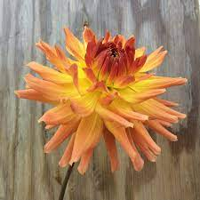 | BLOOMQUIST PAXTON P B SC OR |  | 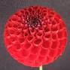 | BLOOMQUIST PAUL JR MB DR |  | 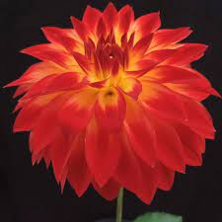 | BLOOMQUIST BB FD FL RD/YL
 | BLOOMQUIST STAN |  | 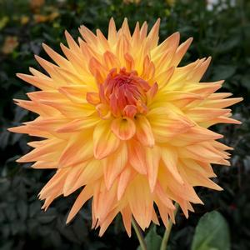 | BLOOMQUIST ROGER B SC LB YL/OR |  | 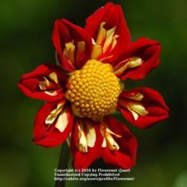 | BLOOMQUIST SPINNER CO RD yl
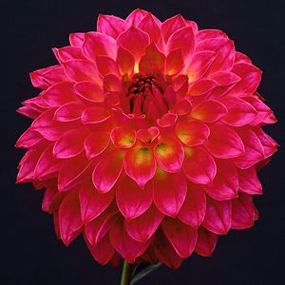 | BLOOMQUIST SUPRISE |  | 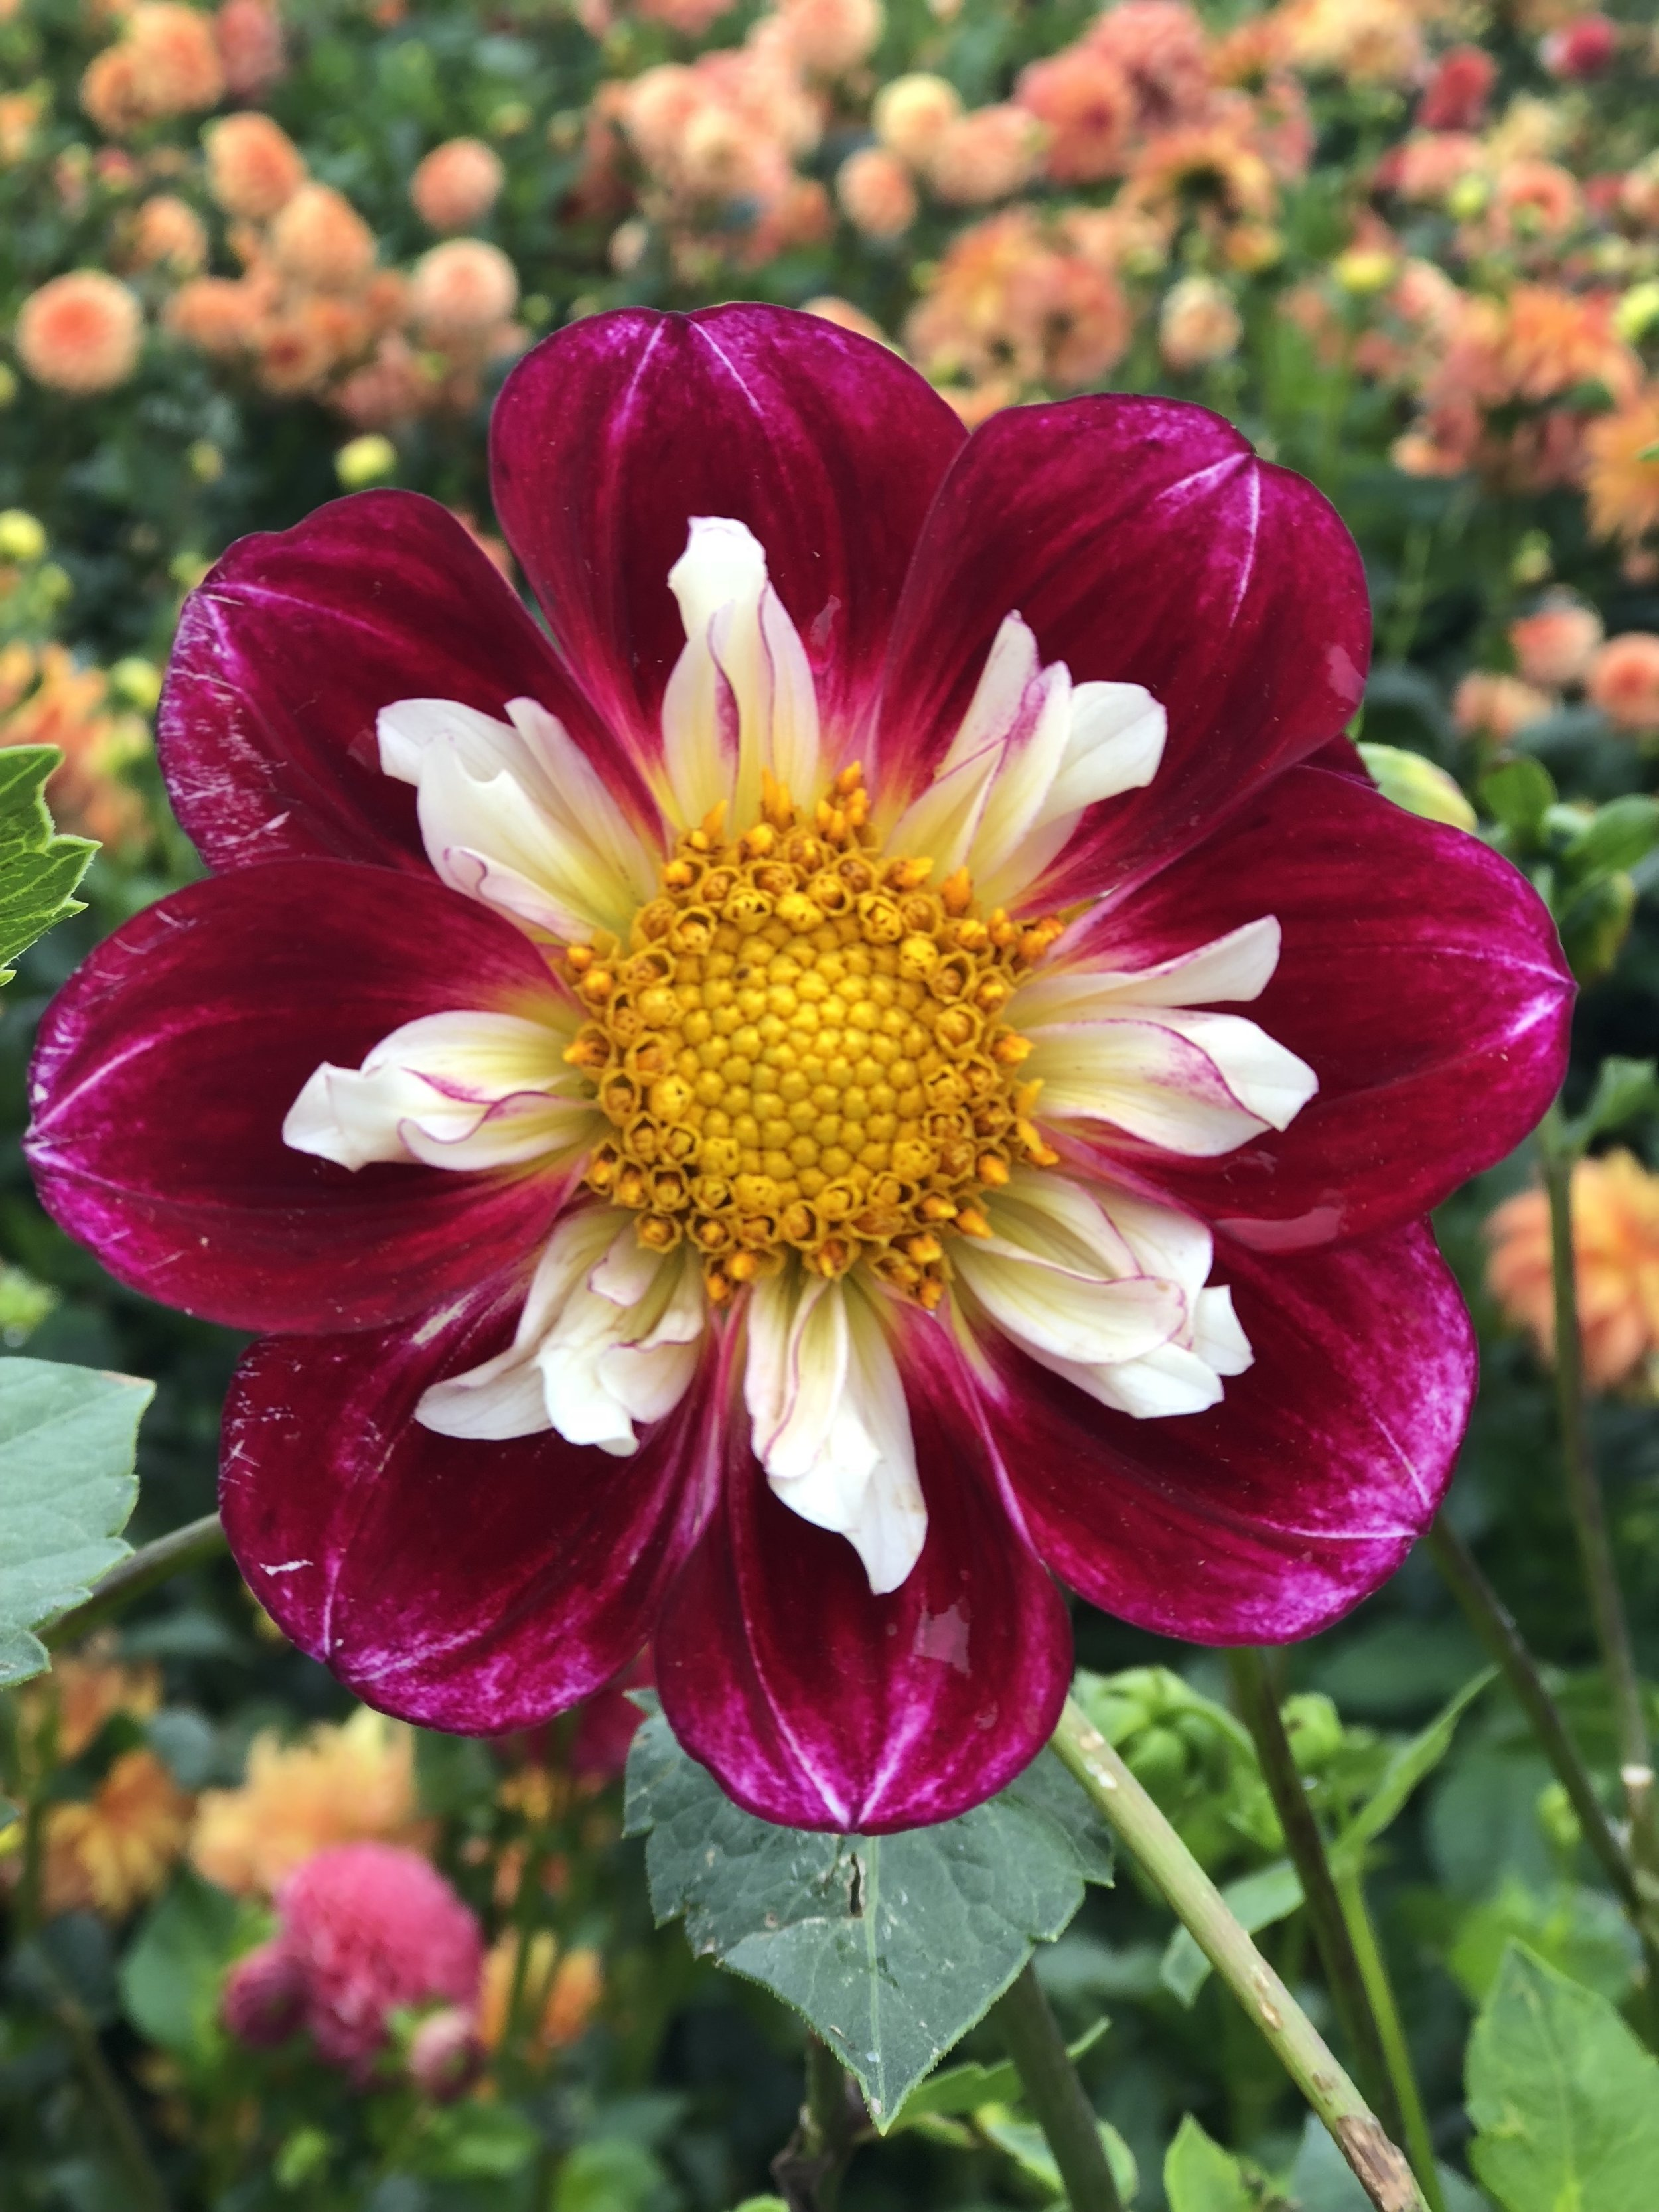 | BLOOMQUIST STEVE R CO DB RD/PK lb wh/l |  |  | BLOOMQUIST ISLA P
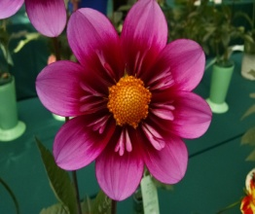 | BLOOMQUIST SWEET CO DB DP/PR db dp/dr |  | 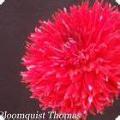 | BLOOMQUIST THOMAS BB LC DR |  | 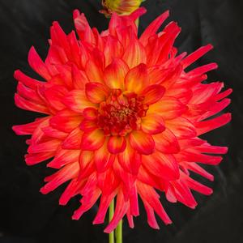 | BLOOMQUIST TROPICAL BB SC DB DR/YL

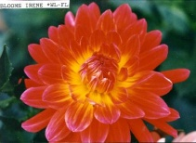 | BLOOM’S  IRENE  WL FL |  | 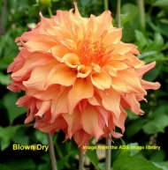 | BLOWN DRY  B ID LB PK/Y |  | 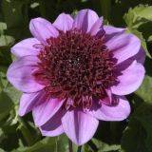 | BLUE BAYOU  AN L L/PR
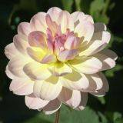 | BLISS  WL LB Y/PK |  | 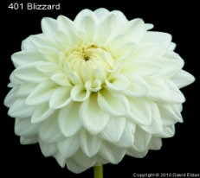 | BLIZZARD  M FD W |  | 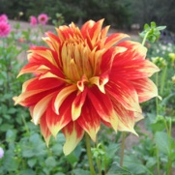 | BODACIOUS  AA ID R
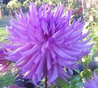 | BODE B IC LV |  | 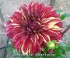 | BOHEMIAN SPARTACUS A ID V PR/Y |  | 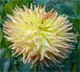 | BO-KAY B SC LB Y/BR
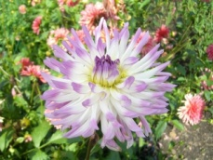 | BOLD ACCENT  BB SC W/L |  | 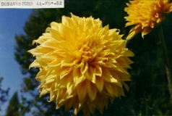 | BON ADVENTURE  AA FD BR |  | 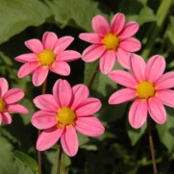 | BONNE ESPERANCE  MS DP
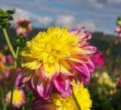 | BOOGIE WOOGIE AN LB |  | 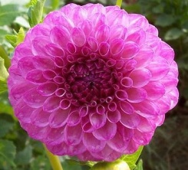 | BRACKEN NIKOLAUS M FD LV |  | 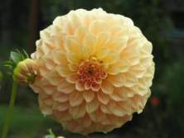 | BRACKEN SARA  BB FD LB Y/PK
 | BRADLEY AARON B ID DB PR WH |  | 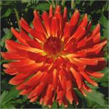 | BRANDON J BB SC O/Y |  | 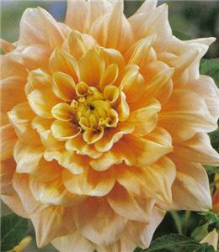 | BREAKOUT  A FD LB O/WH
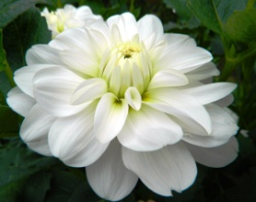 | BRIDE TO BE WL W |  | 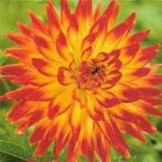 | BRIDGEVIEW ALOHA  A SC FL |  | 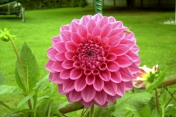 | BRIAN R.  B FD L
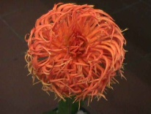 | BRIGHT STAR  BB IC O |  | 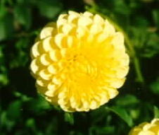 | BRISTOL CANARY  M FD Y |  | 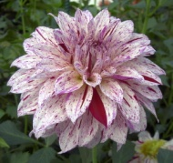 | BRISTOL FLECK  BB FD V W/PR
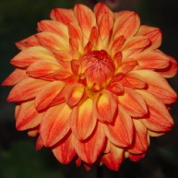 | BRISTOL DANDY  M FD DB Y/O |  | 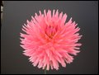 | BRISTOL KARMA  BB SC PK |  | 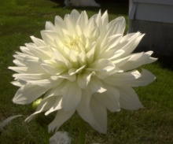 | BRISTOL SNOWFLAKE  BB C W
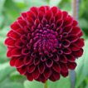 | BRISTOL SPARTAN  M FD DR |  |  | BRISTOL STRIPE  A ID V W/L/PR |  | 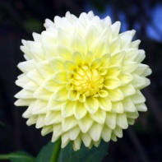 | BRISTOL SUNNY  M SC Y
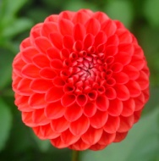 | BRISTOL TANGERINE  M FD O |  | 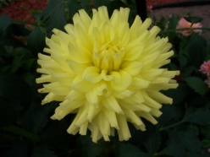 | BROOKSIDE J. COOLEY  M ID Y |  | 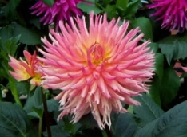 | BROOKSIDE CHERI  BB C PK
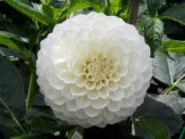 | BROOKSIDE SNOWBALL  B W |  | 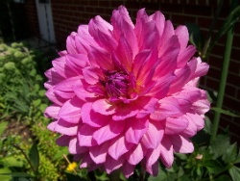 | BRUSH STROKES  M ID L |  | 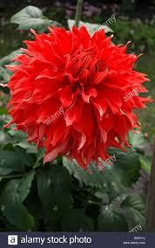 | BRYN TERFEL AA ID RD
 |  |  |  | BO-KAY B SC LB Y/BR
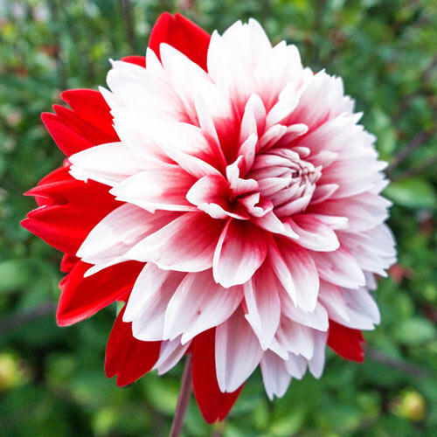 | BURLESQUE BB ID DB RD WH |  | 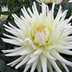 | CABANA  BANANA  B SC Y/W |  | 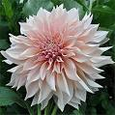 | CAFÉ AU LAIT B ID PK
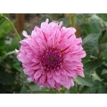 | CALICO ROSE |  | 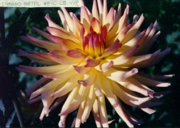 | CAMANO ARIEL  B C LB Y/PK |  | 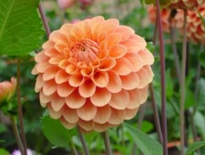 | CAMANO BUZ  M FD O
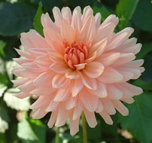 | CAMANO CLOUD  BB SC PK |  | 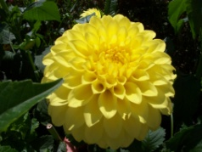 | CAMANO DEREK  B FD Y |  | 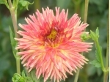 | CAMANO IMP BB C R/Y
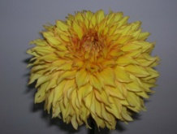 | CAMANO HONEY  B ID BR |  | 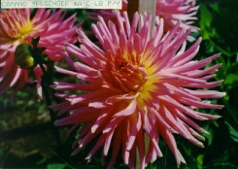 | CAMANO MESSENGER  A IC LB PK/Y |  | 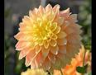 | CAMANO BRAM A FD LB OR/YL
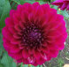 | CAMANO PHANTOM BB FD PR |  | 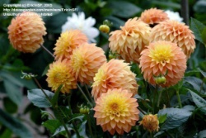 | CAMANO PET  ST LB Y/O |  | 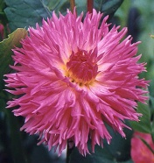 | CAMANO PUFF  BB LC LB p/l
 | CAMANO RASCAL B IC BI RD/WH |  | 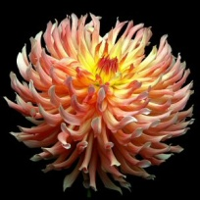 | CAMANO SITKA  B IC DB BR/Y |  | 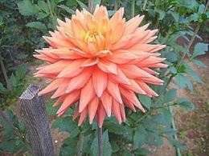 | CAMANO SUSAN BB SC OR
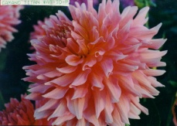 | CAMANO TITAN  AA ID PK |  | 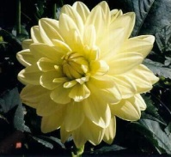 | CAMEO  WL Y |  | 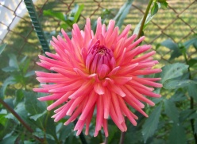 | CAM KUI SEA MIST  BB C DP
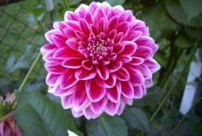 | CANBY CENTENNIAL  BB FD DPK |  |  | CANDLE LIGHT B SC Y |  | 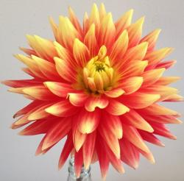 | CANDY CORN BB FL OR/YL
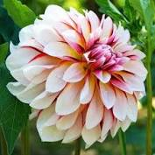 | CARIBBEAN FANTASY BB FD V WH/RD |  | 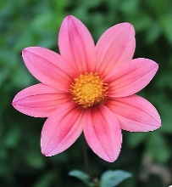 | CARL S DP |  | 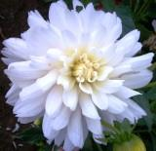 | CARL CHILSON BB ID W
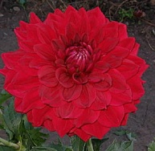 | CAPROS  JERRY GARCIA  B FD R |  | 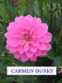 | CARMEN BUNKY WL DP |  | 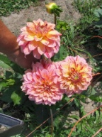 | CARMEN FIESTA  B FD V PK/R/Y
 |  |  | 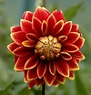 | CARNIVALE BB ID FL RD/YL
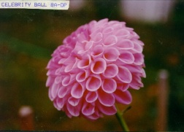 | CELEBRITY BALL  BA DP |  | 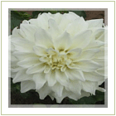 | CENTER COURT  B FD W |  | 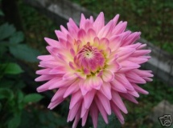 | CG ELEGANCE  BB C L
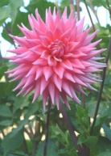 | CG PARAGON  BB SC DP |  | 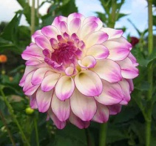 | CG REGAL  BB FD DB W/PR |  | 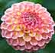 | CG SPRITE M FD LB DP/Y
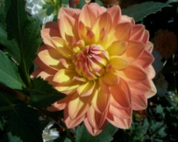 | CHARLIE DIMMOCK WL OR OR
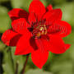 | CHERRY DROP WL RD |  | 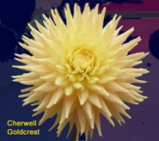 | CHERWELL GOLDCREST  BB SC Y |  | 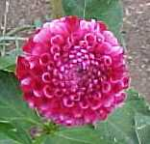 | CHICKADEE  MB LB Y/BR
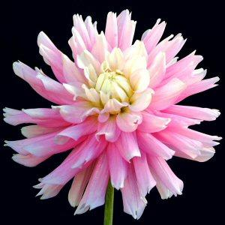 | CHILSON’S PRIDE  BB ID LB W/P |  |  | CHIMACUM JULIA B IC Y |  | 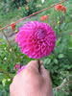 | CHIMACUM KATIE BB FD L

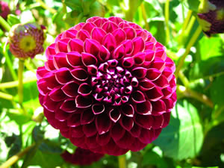 | CHIMACUM  TROY  MB PR |  | 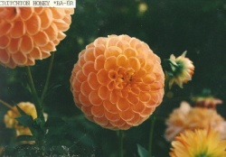 | CHRICHTON HONEY  BA BR |  | 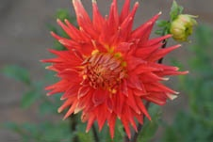 | CINNABAR  AA SC R
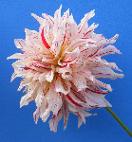 | CISCO BB ID V WH/RD |  | 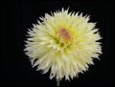 | CITRON DU CAP  B LC Y |  | 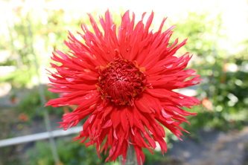 | CLACK’S ROCKY BB LC R
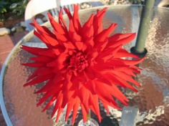 | CLARA HUSTON  AA IC O |  | 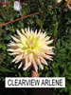 | CLEARVIEW ARLENE A SC PK/YL |  | 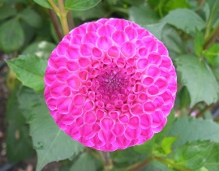 | CRAZY CLEERE’S  MB DB
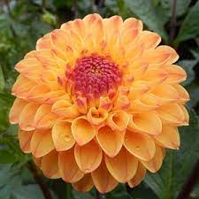 | CLEARVIEW BUTTER SCOTCH M FD LB O/Y |  | 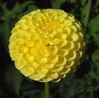 | CLEARVIEW DANIEL BA Y |  | 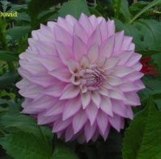 | CLEARVIEW DAVID  BB FD L
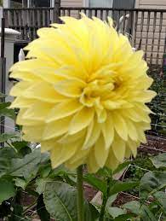 | CLEARVIEW DE SOL ST YL |  | 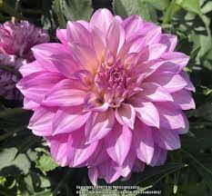 | CLEARVIEW LILA ST LV |  | 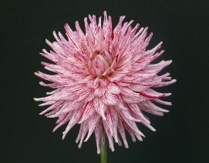 | CLEARVIEW MOTLEY B SC V WH/PR
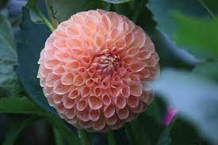 | CLEARVIEW PEACHY BA PK |  | 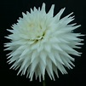 | CLEARVIEW TAMMY B SC W |  | 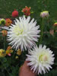 | CLEARVIEW ORCA B SC W
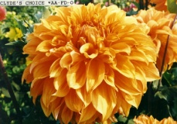 | CLYDE’S CHOICE  AA FD OR |  | 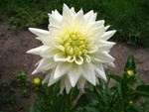 | COLLECTOR  BB SC Y |  | 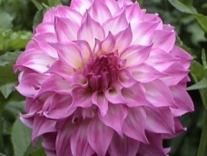 | COLORADO CLASSIC BB ID LB PK/W
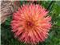 | COLWOOD SCHERI B LC V DR/YL |  | 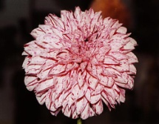 | CONNECTICUT  DANCER  BB FD V W/R |  | 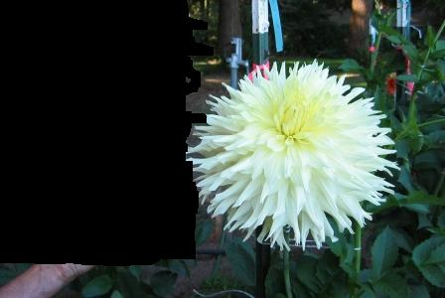 | CONQUISTADOR  AA SC O
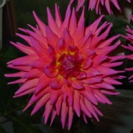 | CONWAY  BB SC DP |  | 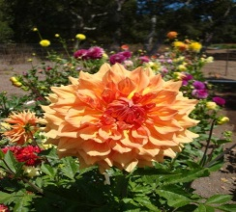 | COOL LUKE A ID BR |  | 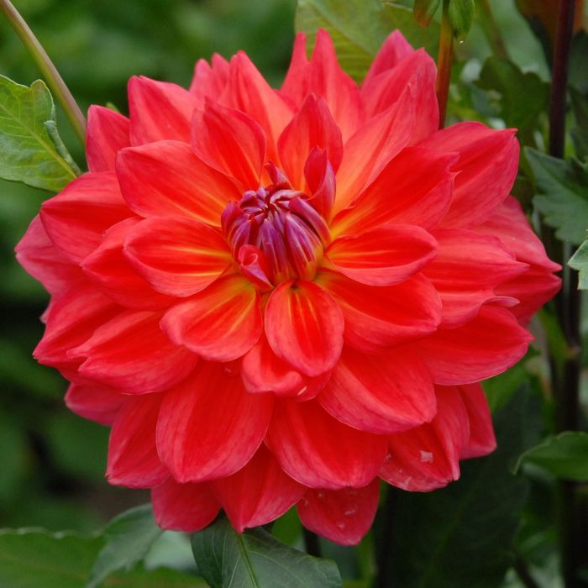 | COOPER BLAINE BB ID RD
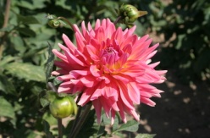 | CORAL GYPSY  B SC DP |  | 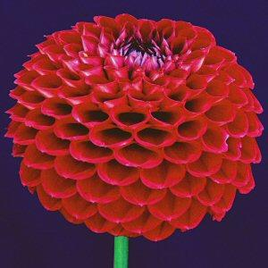 | CORNEL  BA DR |  | 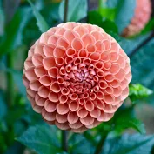 | CORNEL BRONZE BA BR

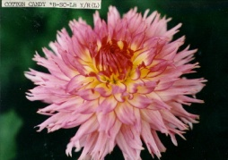 | COTTON CANDY  B SC LB Y/R |  | 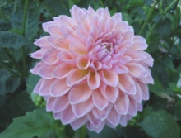 | COUNTRY CHARM  B FD LB PK/Y |  | 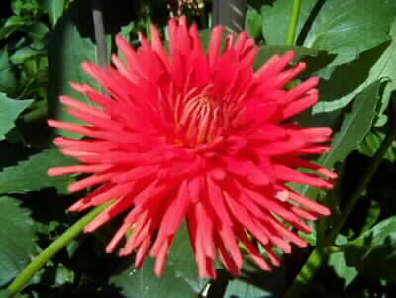 | COUNTRY CUTIE  BB IC O
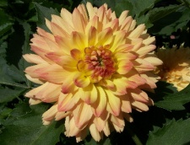 | COUNTRY  HY-LITE  BB ID LB Y/O |  | 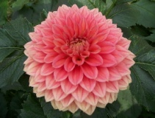 | COUNTRY ROSE  BB FD BR |  | 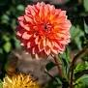 | COUNTRY SWEETHEART BB FD OR
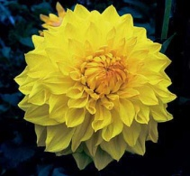 | COUNTRY SUNSHINE  BB ID Y |  | 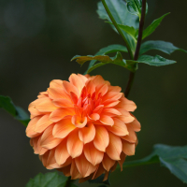 | CRAIG CHARLES BB ID BR |  | 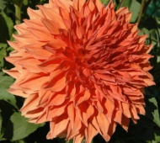 | CRYODON MASTERPIECE  AA ID BR
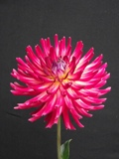 | CRAZY 4 JESSIE BB IC DB DR/YL |  | 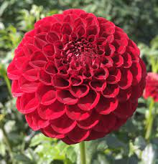 | CRAZY 4 IEASHIA M FD DR |  | 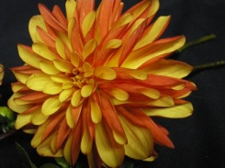 | CRAZYLEGS  ST O
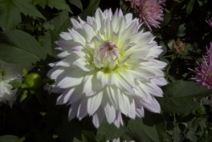 | CRAZY LOVE  BB ID W |  | 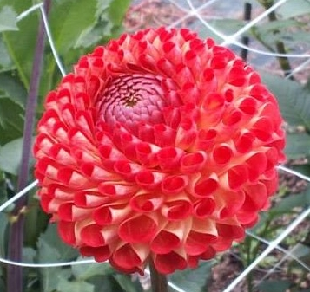 | CRAZY MARY MB FL RD/YL |  | 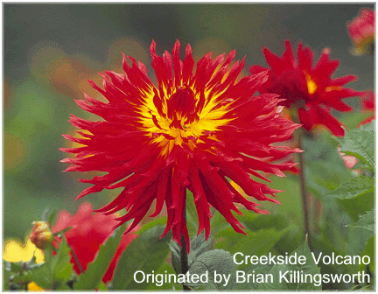 | CREEKSIDE  VOLCANO  B LC FL
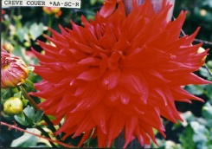 | CREVE COUER  AA SC R |  | 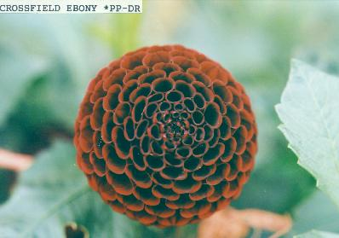 | CROSSFIELD  EBONY  P DR |  | 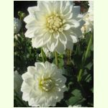 | CRYSTAL VALLEY  M FD W
 | CUTIE PATOOTIE WL DP |  | 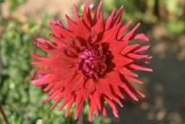 | CYNTHIA HUSTON  A SC R |  | 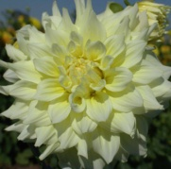 | CYNTHIA LOUISE  A FD Y
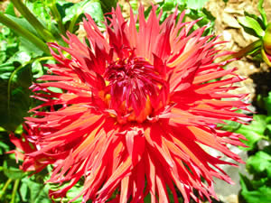 | CYRIL HIGGO  A LC R |  | 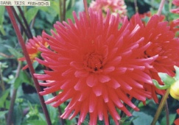 | DANA IRIS  BB SC R |  | 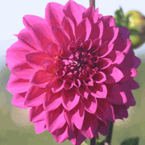 | DANAE  BB FD L
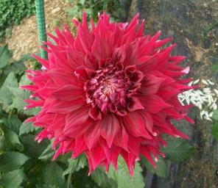 | DANUM METEOR  AA SC R |  | 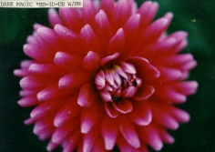 | DARK MAGIC  BB ID DB PR/L |  | 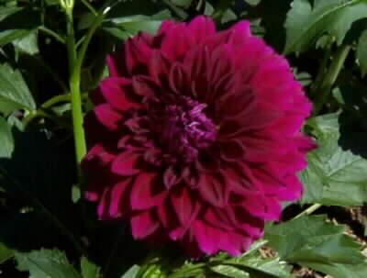 | DARK PRINCE  BB RD PR
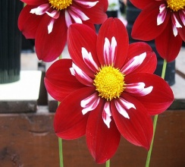 | DARK SUSPENSE CO DR |  |  | DAUNTLESS AA SC R |  | 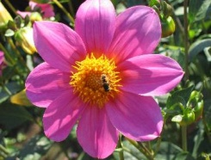 | DELTA COQUETTE  S PK
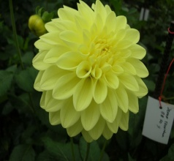 | DEVON ECLIPSE BB FD Y |  | 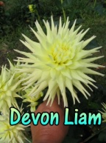 | DEVON LIAM  MB PR |  | 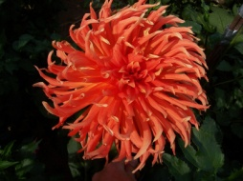 | DESERT GLOW  A C OR
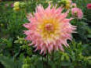 | DICK WESTFALL A ID LB PK/Y |  | 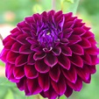 | DIVA BB FD PR |  | 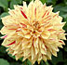 | DIXIE’S WINEDOT A ID V W/PR
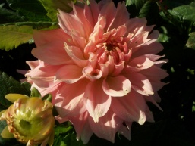 | DOLLY  B ID PK |  | 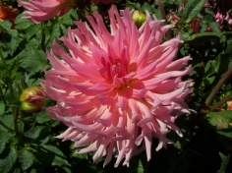 | DORIS B,  A C LB PK/Y |  | 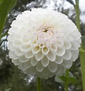 | DOROTHY R. MB W
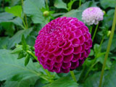 | DOT COM  P PR |  | 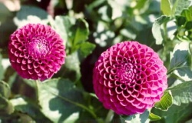 | DOWNHAM ROYAL  MB PR |  | 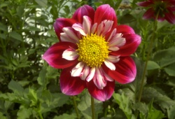 | DOUBLE TROUBLE  CO R/WH
 |  |  | 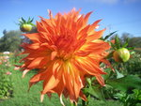 | DR JOHN E KAISER B ID FL
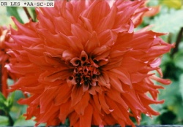 | DR LES  AA SC R |  | 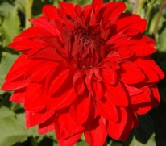 | DRUMMER  BOY  A FD DR |  | 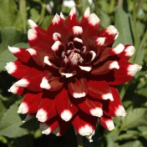 | DUET  B FD BI R/W
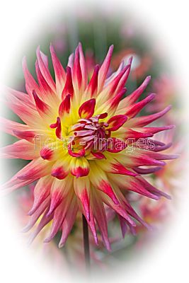 | ELECTRIC FLASH B C DB R/Y |  | 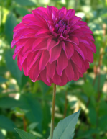 | EARL MINER  BB FD PR |  | 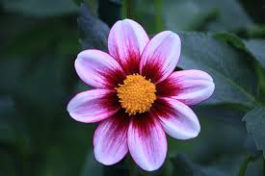 | ECLIPSE S DB DP/LV
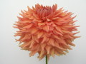 | EDEN TALOS A SC BR |  | 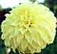 | EDNA C.  B FD Y |  | 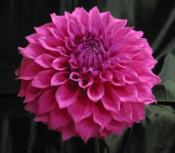 | ELMA ELIZABETH  A FD L
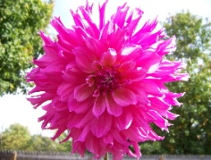 | ELSIE HUSTON  A ID PK |  | 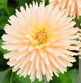 | EMBRACE  BB SC Y |  | c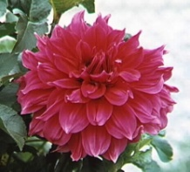 | EMORY PAUL  AA ID PR
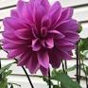 | EMPEROR  B FD PR |  | 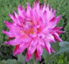 | ENCHANTRESS BB SC DB PR/WH |  | 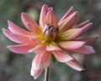 | ENCHANTMENT  ?
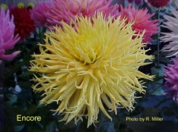 | ENCORE  A LC Y |  | 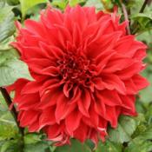 | ENVY  AA ID R |  | 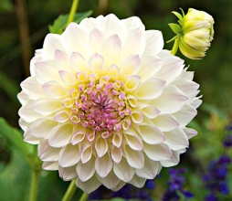 | EVELINE BB FD LB W/L
 |  |  |  | FANCY PANTS OT L |  | 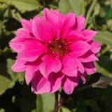 | FASCINATION  M PE LAV
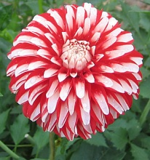 | FELIDA STARS AND STRIPES  BB FD R/W |  | 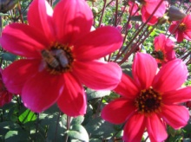 | FERNCLIFF BLACK OUT S R {black leaf] |  | 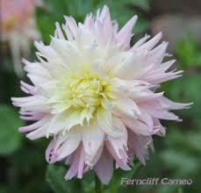 | FERNCLIFF CAMEO BB LC LB PK/WH
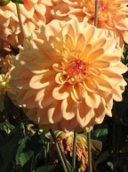 | FERNCLIFF COPPER  BB FD BR |  | 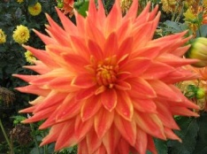 | FERNCLIFF FUEGO  B SC FL |  | 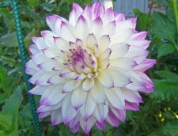 | FERNCLIFF ILLUSION  A ID LB W/L
 |  |  |  | FERNCLIFF LEMON AURA BB C Y
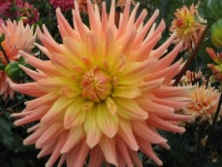 | FERNCLIFF PRELUDE  B C LB O/Y |  |  | FERNCLIFF PURITY M FD P |  | 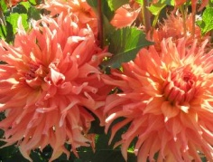 | FERNCLIFF SUNSET  B ID OR
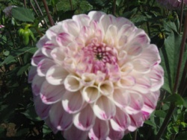 | FERNCLIFF TANGO  M RD W/PR |  | 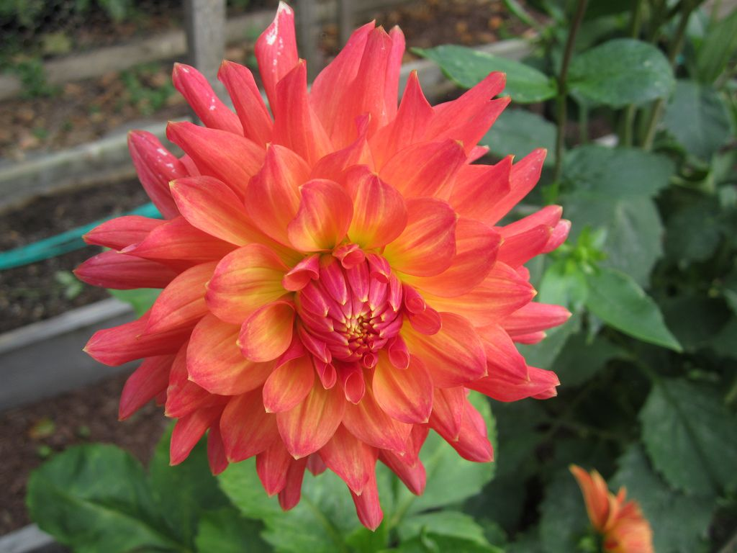 | FERNCLIFF TROPICS BB ID FL YL/RD |  | 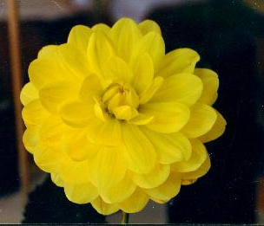 | FERN IRENE  WL Y
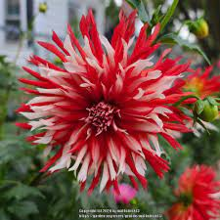 | FIDALGO CLOWN ST ID R/W |  | 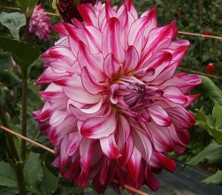 | FIDALGO SPLASH B ID BD PR/W |  | 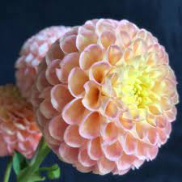 | FIONA BA LB OR/YL
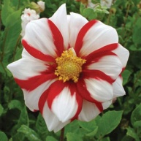 | FIRE AND ICE  PE BI R/W |  | 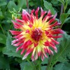 | FIRE BIRD A C DB R/Y |  | 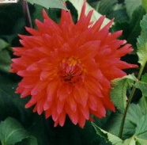 | FIRE MAGIC  B SC FL RD/YL
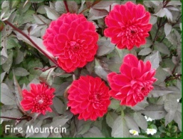 | FIRE MOUNTAIN  BB FD R |  | 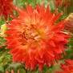 | FIRED UP B SC FL |  | 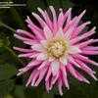 | FIRST KISS BB SC LB P W
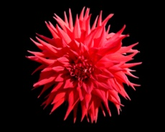 | FISHERMAN  A SC R |  | 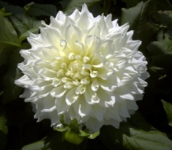 | FLEUREL  AA FD W |  | 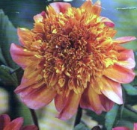 | FLOORINOOR  AN O/P/Y
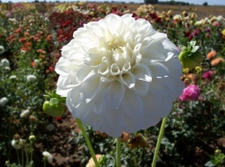 | FORMBY ALPINE  BB FD W |  | 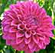 | FORMBY KAITLYN  AA FD PR |  | 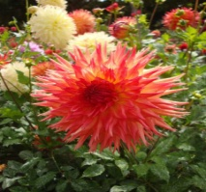 | FORSYTHIA  B LAC Y/OR
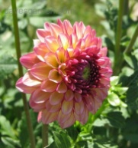 | FOXY LADY  M FD DB DP/Y |  | 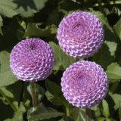 | FRANK HOLMES  P L |  | 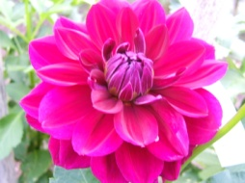 | FREEMONT’S MEMORY  BB ID PR
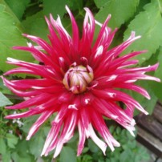 | FRIGOULT BB C DB R/W |  | 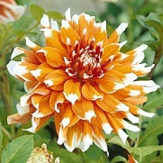 | FROST NIP  A ID DB  BR/R/WH |  | 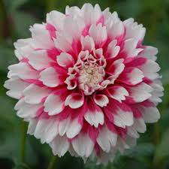 | FUZZY WUZZY  M FD  BI PK/W
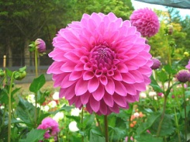 | GALA PARADE BB FD L |  | 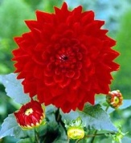 | GARDEN WONDER  A FD R |  | 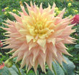 | GARGANTUANAA SC LB PK/Y
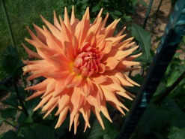 | GARY BB SC O |  | 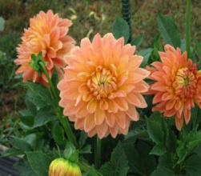 | GATESHEAD ANGEL  B FD OR
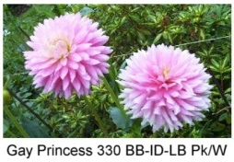 | GAY PRINCESS  BB ID LB W/PK |  | 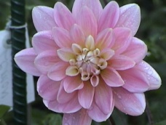 | GERRIE HOEK WL PK |  | 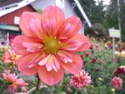 | GIGGLES COL ORG/ROSE
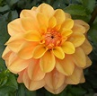 | GINGER SNAP WL LB Y/BR |  |  | GITT’S ATTENTION BB ID W |  | 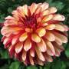 | GITTS CRAZY ST DB DR/YL
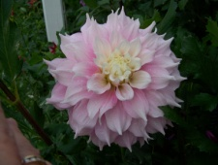 | GITTS PERFECTION  A ID LB L/W |  | 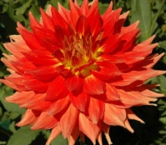 | GLADIATOR  AA ID O |  | 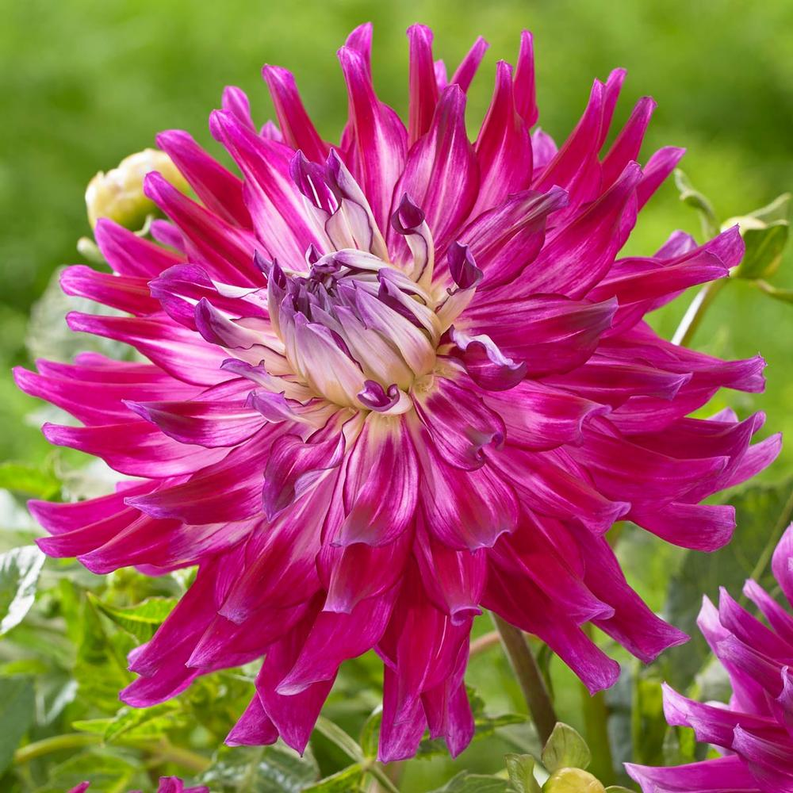 | GLAMOUR GIRL B SC PR

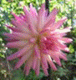 | GLENBANK TWINKLE M C DB W/ LV |  | 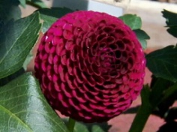 | GLENPLACE  POM PR
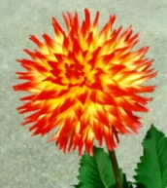 | GLEN VALLEY CATHY |  |  | GLORIE VAN HEEMSTEDE  WL Y |  | 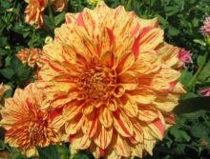 | GLORIOSA  B FD V Y/R
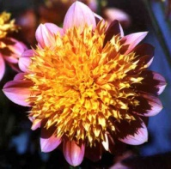 | GOLDIE GULL  AN LB Y/PK |  | 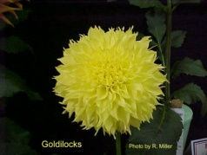 | GOLDILOCKS  BB ID Y |  | 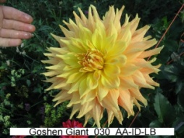 | GOSHEN GIANT  AA ID LB /PK
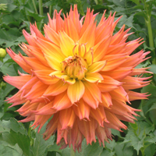 | GRACIE FACE  B LC Y |  | 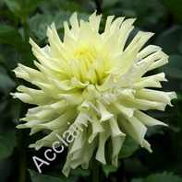 | GRACE WULFF  B SC Y |  | 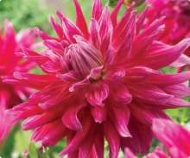 | GRAND FINALE  AA SC DR
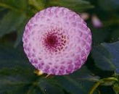 | GRAND WILLO  PP L |  | 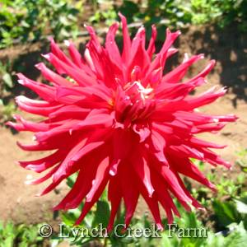 | GREGORY STEPHEN  AA SC R/Y |  | 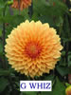 | G WHIZ B FD Y
 |  |  |  |  |  | 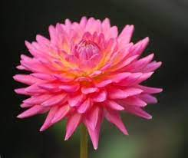 | GW’S BABE M SC LB DP/YL
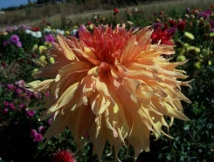 | GW’S MR. DEAN  A LC BR |  |  | GW’S REDMAN BB SC RD |  | 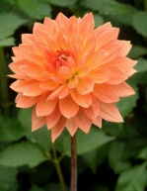 | GWYNETH  WL O
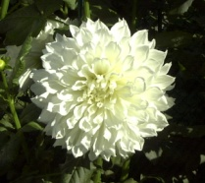 | HAKUYOH  AA FD W |  | 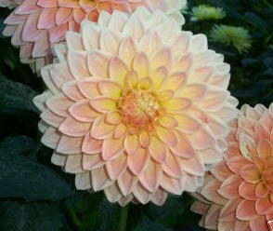 | HAMILTON LILLIAN  BB FD LB |  | 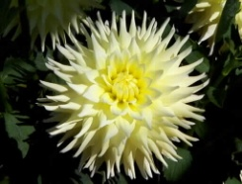 | HAMARI ACCORD  B SC Y
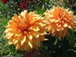 | HAMARI GOLD A ID BR |  | 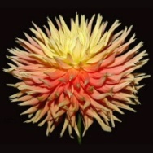 | HANA HITOSUJI  AA C LB PK/Y |  | 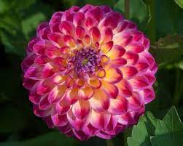 | HAPET DAYDREAM M FD DB DP/YL
 |  |  | 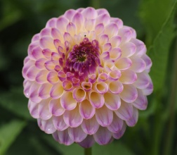 | HAPET PEARL BA LB PR/WH |  | 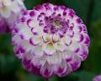 | HAPET TANGO SELECT BB FD LB WH/PR

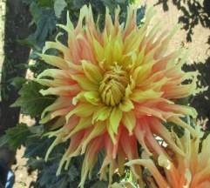 | HARRY MEGGOS A ID LB YL/OR |  | 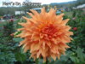 | HART’S Dr. McMURRY AA ID OR |  |  | HARVEST LULLABY
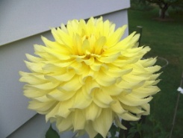 | HARVEST MOONLIGHT A ID Y |  | 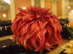 | HARVEY KOOP A ID V DR/YL |  | 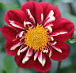 | HEARTTHORB CO RD FL RD/YL
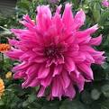 | HELEN RICHMOND B ID L |  | 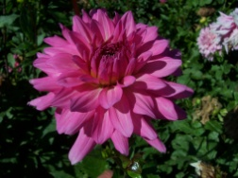 | HERBERT SMITH  BB SC PK |  |  | HEMI JAY M FD LB PK/YL
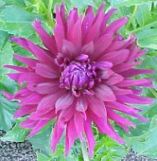 | H G CHAD E  A C PR |  | 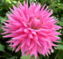 | HIGH BID B DC DP |  | 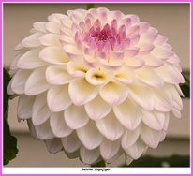 | HIGHFLYER  M FD LB W/L
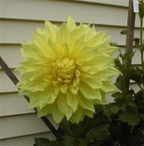 | HIGHLIGHTER  A ID Y |  |  | HILLCREST AMOUR  BB FD W |  | 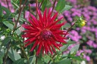 | HILLCREST DUNCAN EDWAEDS B SC DR
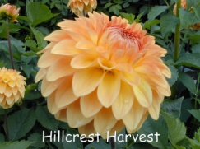 | HILLCREST HARVEST  BB FD LB O/Y |  | 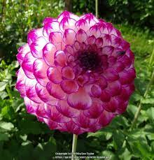 | HILLCREST JONATHAN BB FD DB PR/WH
 |  |  | 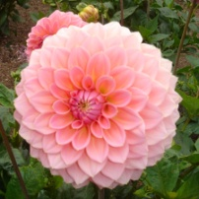 | HILLIER TANUNDA  BB FD PK
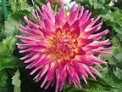 | HILLTOP EMILY B SC DB DP/YL |  | 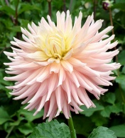 | HILLTOP KELLY  BB SC LB PK/Y |  | 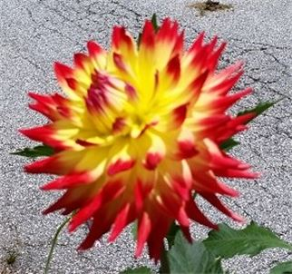 | HILLTOP KEMPER B SC FL YL/RD
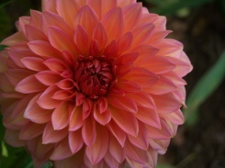 | HILLCREST KISMET  BB FD DP |  | 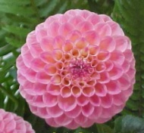 | HILLTOP GLO  BB FD DB P/W |  | 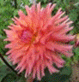 | HILLTOP LOST TREASURE B SC LB DP/YL
 | HILLTOP MAGNUS BB LC FL RD/YL |  | 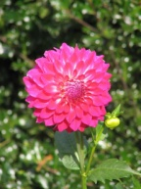 | HILLTOP SAPPHIRE  BB FD DB L/W |  | 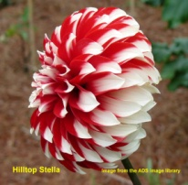 | HILLTOP STELLA  ST BI RD/W
 | HILLTOP SUNFIRE BB SC FL RD YL |  | 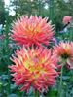 | HILLTOP ST CHARLES B SC FL O/Y |  | 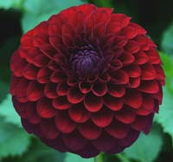 | HILLTOP ONYX M FD DR
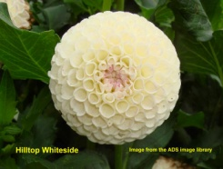 | HILLTOP WHITESIDE  MB W WH |  | 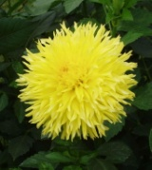 | HISSY FITZ  BB LC Y |  | 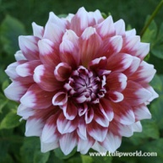 | HOLLAND’S FESTIVAL  A FD BI R/WH
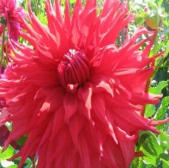 | HOLLY HUSTON AA SC RD |  | 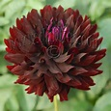 | HOLLYHILL BLACK BEAUTY BB ID DR
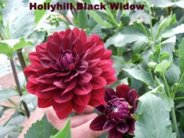 | HOLLYHILL  BLACK WIDOW  WL DR |  | 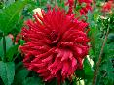 | HOLLYHILL BIG RED  A SC DR |  | 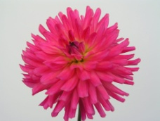 | HOLLYHILL BRIDGET M SC DB DP/YL
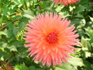 | HOLLYHILL CHLOE B SC DB DP/YL |  | 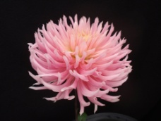 | HOLLYHILL COTTON CANDY B IC DPK |  | 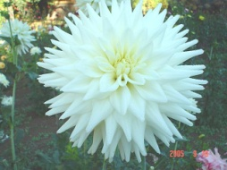 | HOLLYHILL  CRYSTAL  BB SC W
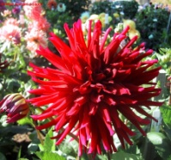 | HOLLYHILL  DARK VICTORY  B C DR |  | 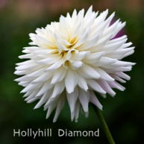 | HOLLYHILL  DIAMOND  BB SC W |  | 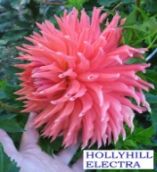 | HOLLYHILL ELECTRA  A IC OR
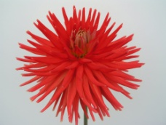 | HOLLYHILL FIRELIGHT  B C R |  | 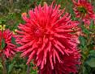 | HOLLYHILL FLAMINGO B SC DP |  | 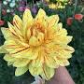 | HOLLYHILL FUNHOUSE A ID V YL/PR
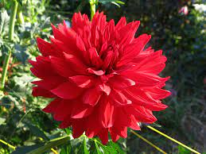 | HOLLYHILL FUNHOUSE RED A ID RD
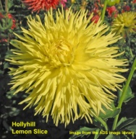 | HOLLYHILL  LEMON SLICE  BB LC Y

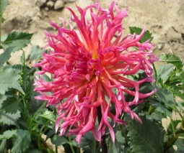 | HOLLYHILL MARGARITA B IC DP |  | 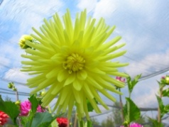 | HOLLYHILL  NIKKO  BB C Y |  | 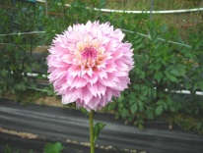 | HOLLYHILL PINKIE  M LC LB PK/W
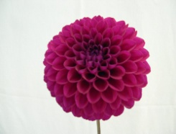 | HOLLYHILL  PURELY PURPLE  M FD PR |  | 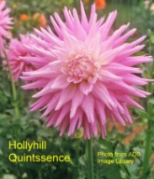 | HOLLYHILL QUINTESSENCE  B SC LB PK/W |  | 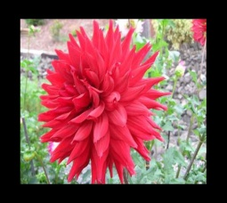 | HOLLYHILL SAMARAI A SC DR
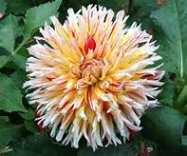 | HOLLYHILL SIX-IN-ONE B LC V YL/RD/WH |  | 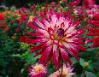 | HOLLYHILL STARBURST BB C DB PR/W |  | 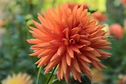 | HOLLYHILL TANGERINE BB SC OR
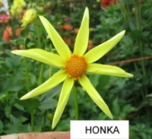 | HONKA  O Y |  | 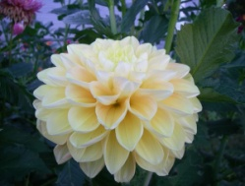 | HONEY DEW BB FD LB PK/Y |  | 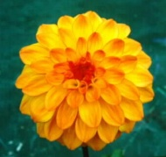 | HY CLOWN  BB FD LB  Y/BR
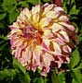 | HY DARCY  B FD V Y/PK |  | 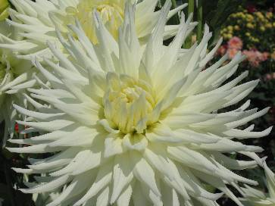 | HY DEBUT  A SC W |  | 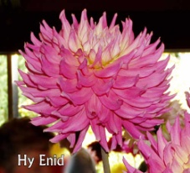 | HY ENID  B SC LB L/Y
 | HY IMPACT  BA V W/PR |  | 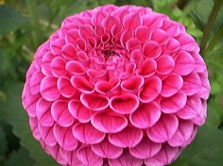 | HY MALLOW  BA PR |  | 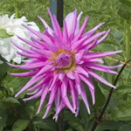 | HY MIRIAM A IC L
 |  |  |  |  |  | 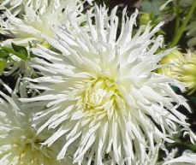 | HY MOM  AA C WH
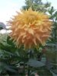 | HARRY MEGGOS A ID LB YL/OR |  | 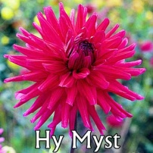 | HY MYST  BB SC P |  | 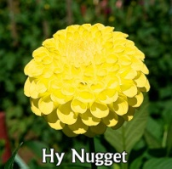 | HY NUGGET  MB Y
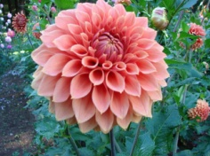 | HY PATTIE  B FD OR |  | 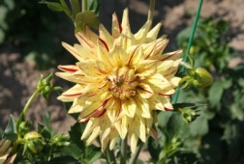 | HY PIMENTO  BB SC V Y/r |  | 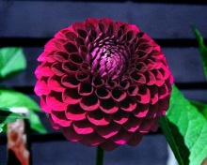 | HY PLUM  B FD PR
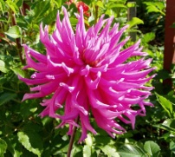 | HY MIRIAM  A IC L |  | 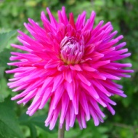 | HY MYST  BB SC PR |  | 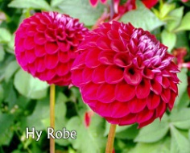 | HY ROBY  BB FD DR
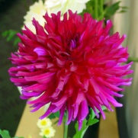 | HY RUDY B  B SC P |  | 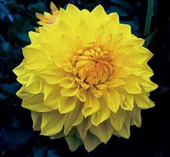 | HY SAFFRON  B ID Y |  | 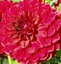 | HY SALVIA  B FD DR
 | HY SOCKEYE  BB FD R |  | 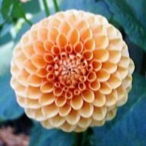 | HY SUNTAN  MB BR |  | 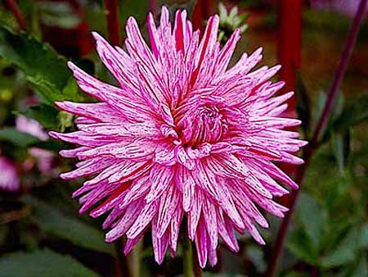 | HY TRIO  B SC V W/PR
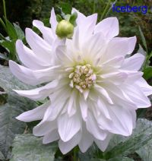 | ICEBERG  AA ID W |  | 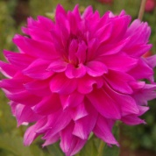 | I’M A HOTTIE B ID PK |  | 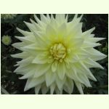 | INCA DAMBUSTER  AA SC Y
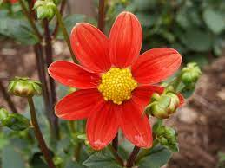 | INFLAMMATION MS OR
 | INEGO M FD DR |  | 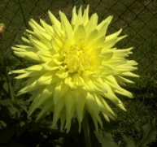 | INLAND DYNASTY  AA SC Y |  | 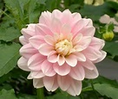 | INNOCENSE WL P
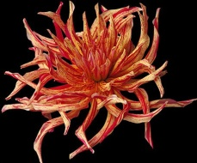 | INSIPIC  NX V |  | 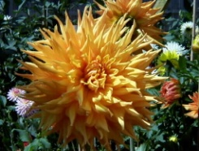 | IRENE’S PRIDE  AA SC BR |  | 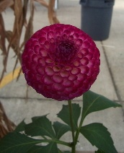 | IRISH MISS  P DB PR/W
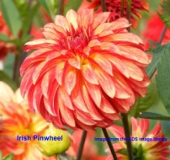 | IRISH PINWHEEL  ST FL YL/RD |  |  | ISLANDER  A ID DPK | 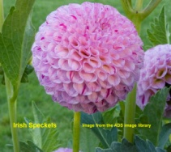
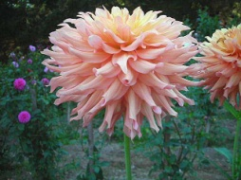 | ISLANDVIEW  TWISTER  B ID BR |  | 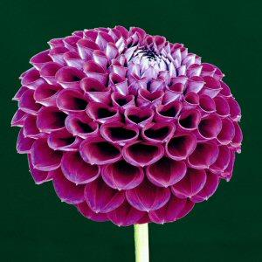 | IVANETTI  BA PR |  | 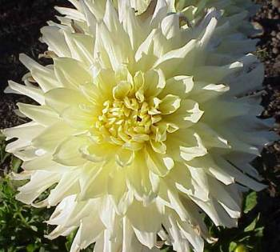 | IVORY PALACES  AA ID Y

 |  |  |  |  |  | JABBERBOX M FD CORAL
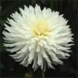 |  | JACK FROST BB SC WH |  |  |  |  |  | 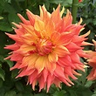 | JACKIE EVANGELISTA A SC DB DP/YL
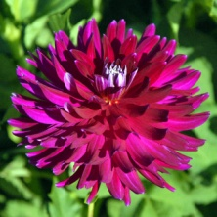 |  | JAMMIN  JELLY  BB SC PR |  | 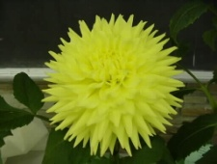 |  | JANAL AMY  A SC Y |  | 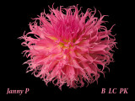 | JANNY P B LC DP
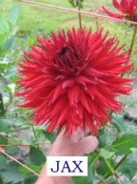 |  | JAX  A LC DR |  | 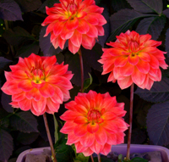 |  | JAYLEEN G.  B WL LB PK/Y |  | 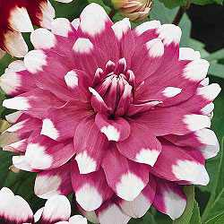 | JEAN MARIE  B FD BI PK/W
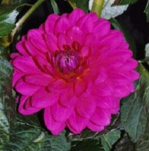 |  | JENNA  BB ID PK |  | 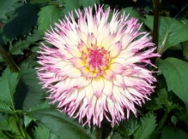 |  | JENNIE  B LC LB PK/WH |  |  | JENNIE LEROUX BB LC LB W/L
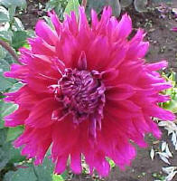 |  | JENNIFER’S  WEDDING  B ID PR |  | 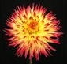 |  | JESSICA  B IC BI Y/R |  | 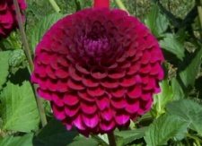 | JESSIE G.  BA PR
 |  | JEWEL HUSTON AA SC LB PK/Y |  | 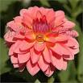 |  | JITTER BUG M FD PK |  | 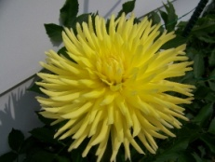 | JO ANNE  B C Y
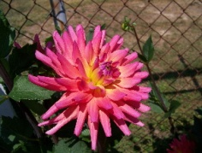 |  | JOE DEIKE  BB SC LB P/Y |  | 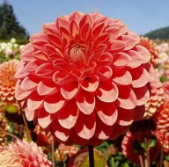 |  | JOMANDA  BB FD R |  |  | JOEY NICHOLE
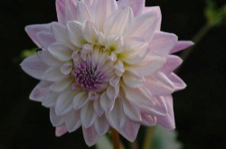 |  | JORDAN NICHOLE  BB ID L |  | 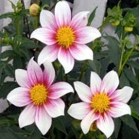 |  | JOSHUA JUUL  S W/P |  | 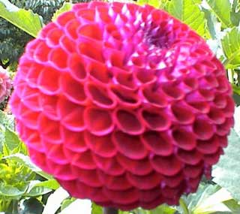 | JOWEY  ANOUSCHKA  BA PR
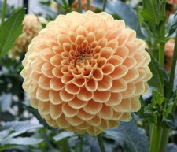 |  | JOWEY INGRID  BB FD O |  | 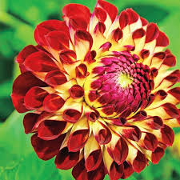 |  | JOWEY JOSHUA BA DB DR/Y
 |  |  |  | 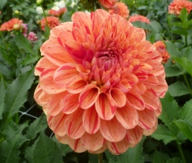 |  | JOWEY NICE BB FD V BR./RD |  |  | JOWEY RITA ST DR
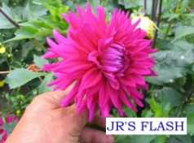 |  | JR’S FLASH  B SC PR |  | 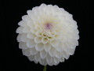 |  | JS ADDIE BB FD W |  | 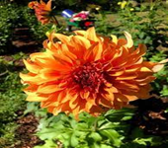 | JS JENNY A ID OR
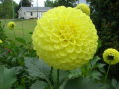 |  | JS LEMON BB FD Y |  | 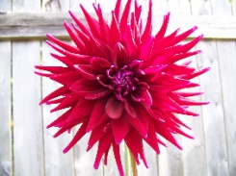 |  | JUANITA  B C DR |  | 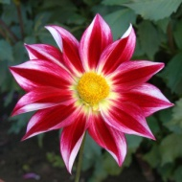 | JUNKYARD DOG  NX DP
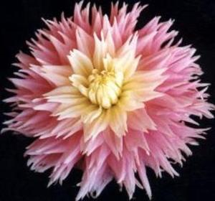 |  | JUST MARRIED  BB LC LB PK/Y |  | 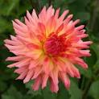 |  | JUST PEACHY BB SC LB PK/YL |  |  | IVORY PALACES  AA ID Y
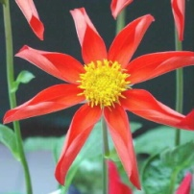 |  | K-K-K-KATIE  O O/or |  | 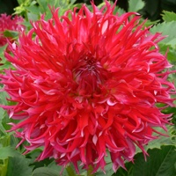 |  | KAETLYN BB LAC RD |  | 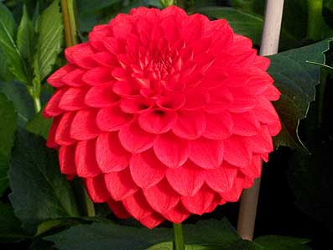 | KARENGLEN  M FD R
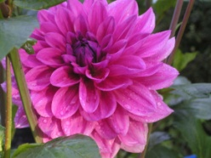 |  | KARI BLUE  WL L |  | 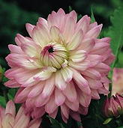 |  | KARMA AMANDA  WL LB W/PK |  | 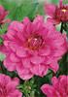 | KARMA LAGOON
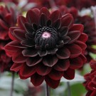 |  | KARMA CHOC WL DR |  | 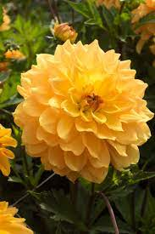 |  | KARMA GOLD B FD YL
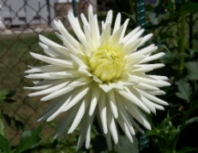 |  | KARRAS 150  BB C WH |  | 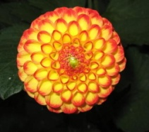 |  | KASASAGI  P Y/R |  | 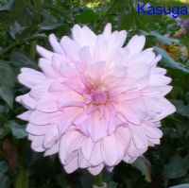 | KASUGA  A ID PK
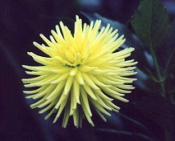 |  | KATHY’S CHOICE  M C Y |  | 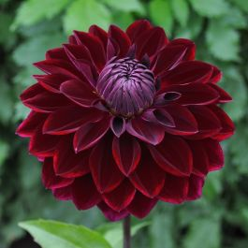 |  | KEISHA LEA BB FD DR |  | 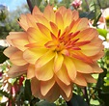 | KEITH H WL LB Y/R
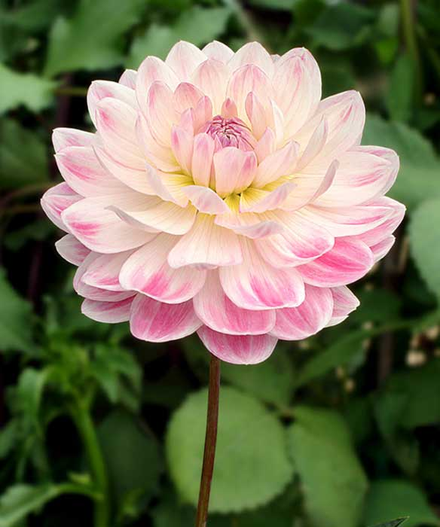 |  | KELGAI ANN WL LB WH/PK/DP |  | 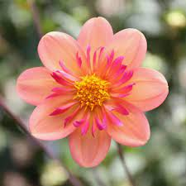 |  | KELSEY ANNIE JOY CO OR/dp |  | 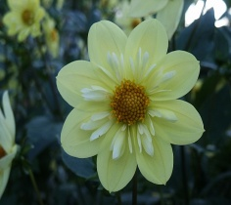 | KELSEY SUNSHINE CO Y
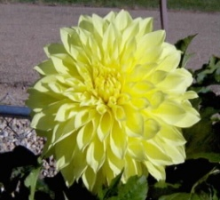 |  | KELVIN FLOODLIGHT  AA FD Y |  | 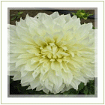 |  | KELVIN WHITE  AA FD W |  | 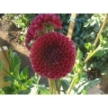 | KEN’S CHOICE BA DR
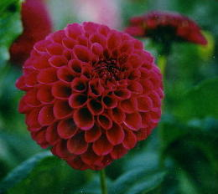 |  | KENORA AMETHYST  BA PR |  | 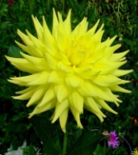 |  | KENORA CANADA  B SC Y |  | 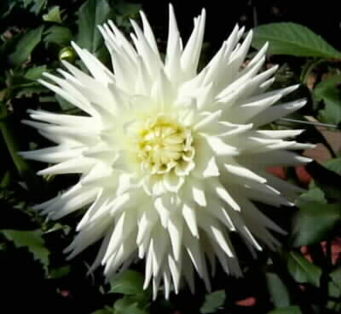 | KENORA CHALLENGER  B SC W
 |  |  |  | 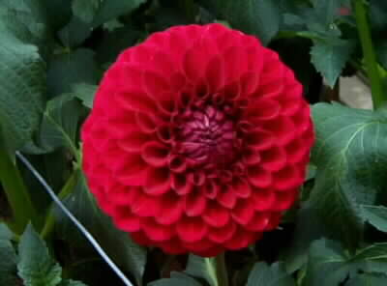 |  | KENORA CHRISTMAS  BB FD R
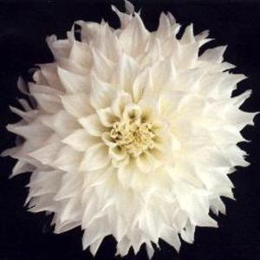 |  | KENORA CLYDE  A SC W |  | 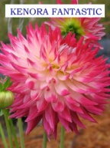 |  | KENORA  FANTASTIC  B SC DB W/PR |  | 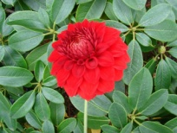 | KENORA  FIRE F IGHTER  B FD R
 |  |  |  |  |  |  |  | 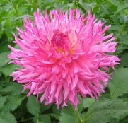 | KENORA  FRILLS  B LC DPK
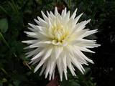 |  | KENORA JUBILLEE  A SC W |  | 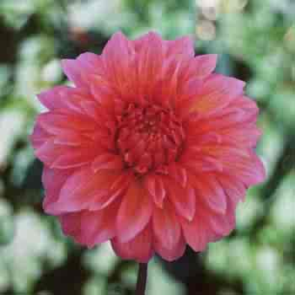 |  | KENORA LISA  B RD PK
 |  |  |  | 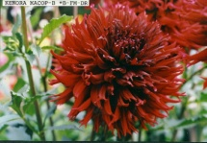 |  | KENORA MACOP-B  B FD DR |  | 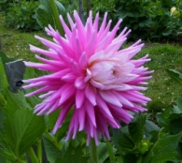 | KENORA MAJESTIC  B C LB L/W
 |  |  |  | 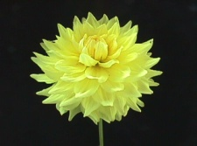 |  | KENORA MOONBEAM  BB ID Y |  | 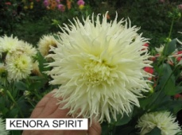 | KENORA  SPIRIT  B LC W
 |  | KENORA SUNBEAM |  | 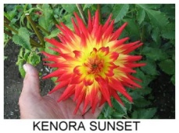 |  | KENORA SUNSET  B SC FL |  | 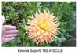 | KENORA SUPERB A SC LB OR/YL
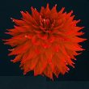 |  | KENORA WILDFIRE  A ID R |  | 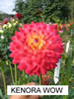 |  | KENORA WOW  B SC DB DR/PK |  | 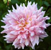 | KIDD’S CLIMAX  A FD LB PK/Y
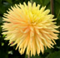 |  | KIM BAKER BB SC LB YL/OR |  | 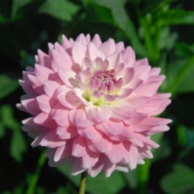 |  | KISS ME M FD LB L/W |  | 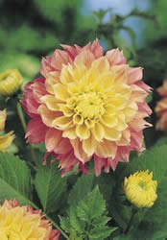 | KOGANE FUBUKI  B FD LB P/Y
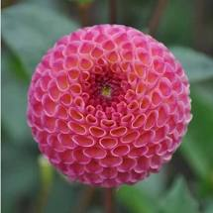 |  | KOKO PUFF P L |  | 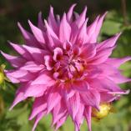 |  | KYLE HUSTON  A ID L |  | 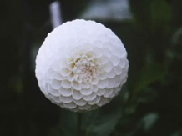 | L’ANCRESSE  BA WH
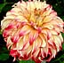 |  | LADY DARLENE B FD DB R Y |  | 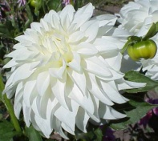 |  | LADY LIBERTY  B FD W |  | 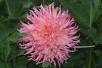 | LAKEVIEW CURLEY B LC LB DP/YL
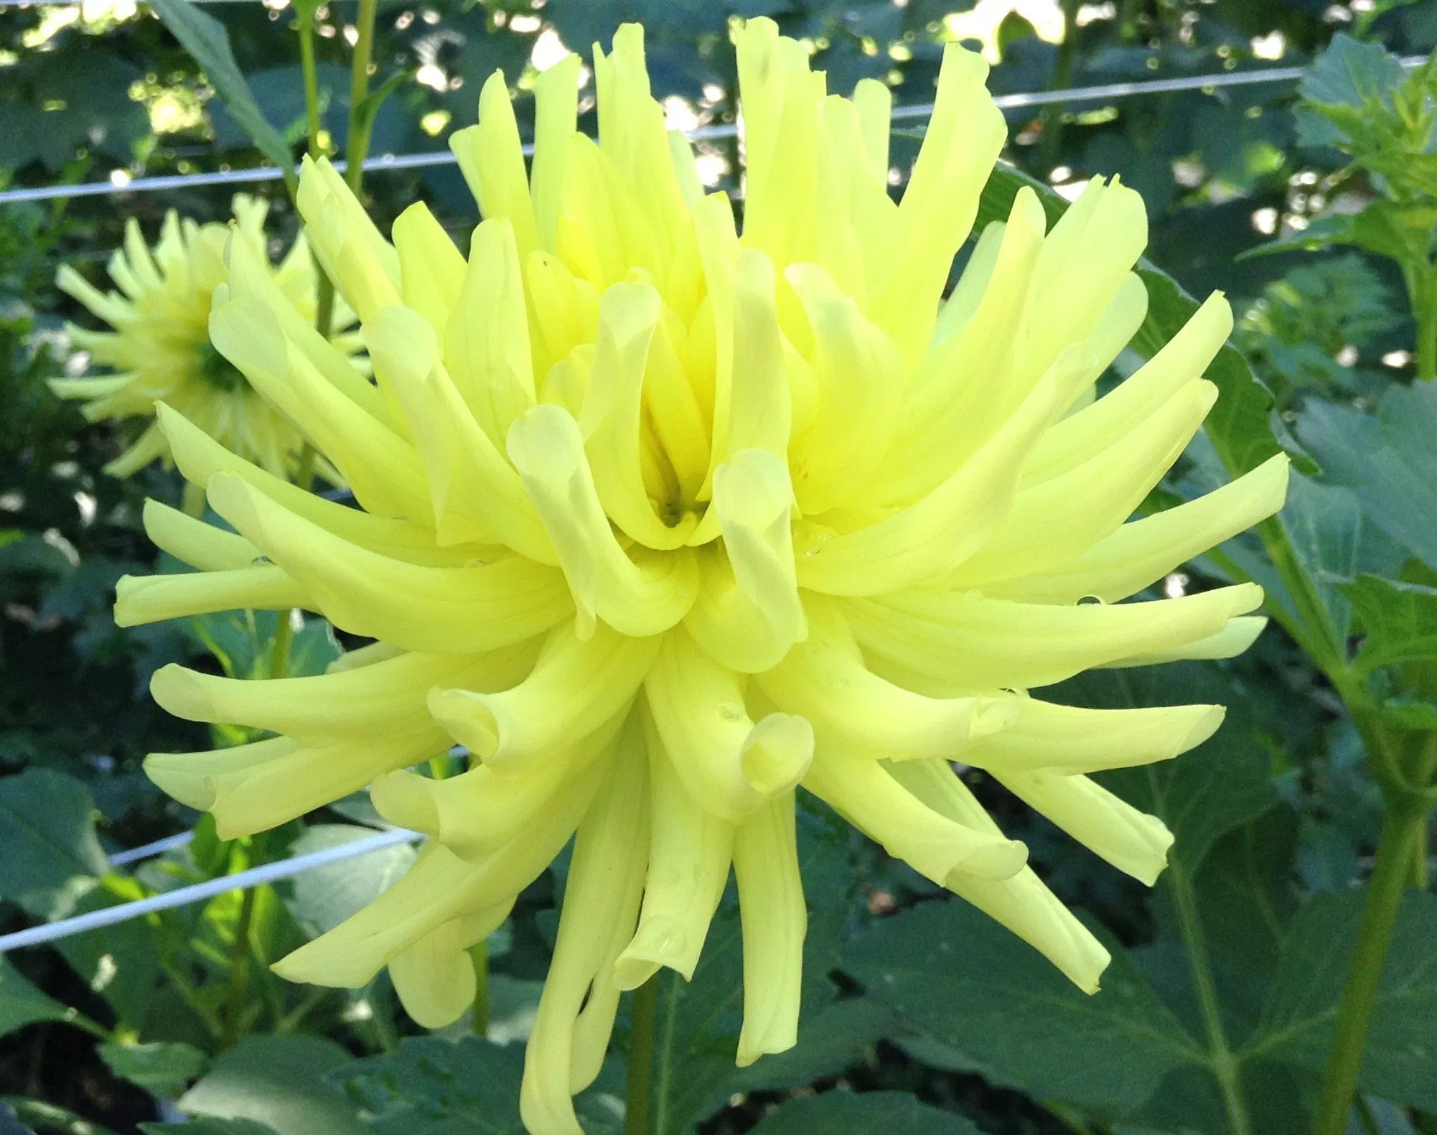 |  | LAKEVIEW GLOW BB IC Y |  | 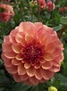 |  | LAKEVIEW LUCKY BB FD LB PK/YL |  | 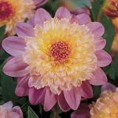 | LAMBADA  AN LB L/W
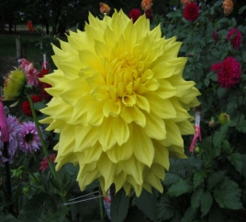 |  | LAREDO  A FD Y |  | 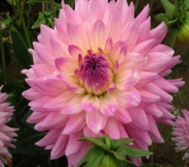 |  | LARK’S AMBER BLAIR B SC LB W/L |  | 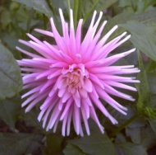 | LAURA’S DREAM  M C PK
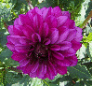 |  | LAUREN MICHELLE WL L |  | 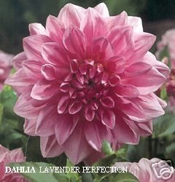 |  | LAVENDER PERFECTION  A ID L |  | 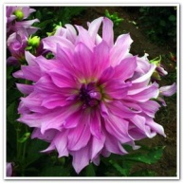 | LAVENDER RUFFLES  AA ID L
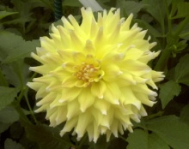 |  | LEMON MERENGUE  BB ID BI Y/W |  | 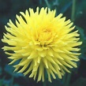 |  | LEMON TART BB C YL |  | 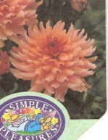 | LEONARDO  BORDER  M O/CORAL
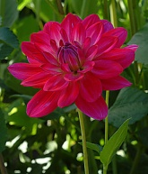 |  | LEOTA MACE  WL DPK |  | 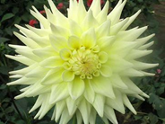 |  | LIGHT ACCORD  B SC Y |  | 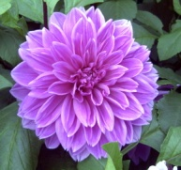 | LILAC TIME  BB FD L
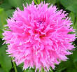 |  | LILLIAN STUART  B LC DP |  |  |  | LIPSTICK  B LC BI PK/Y |  | 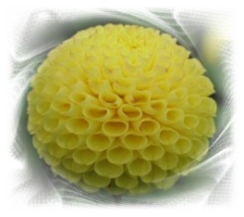 | LISMORE MOONLIGHT  P Y
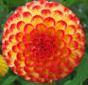 |  | LITTLE BEESWINGS P FL YL/RD |  | 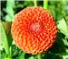 |  | LITTLE CAESAR MB OR |  | 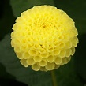 | LITTLE SCOTTIE P YL
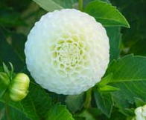 |  | LITTLE WILLO  P WH |  | 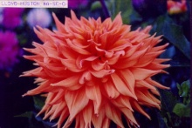 |  | LLOYD HUSTON |  | 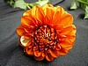 | LOLLIPOP POM O/RD 1 W PETAL
 |  | LOREDO A FD YL |  | 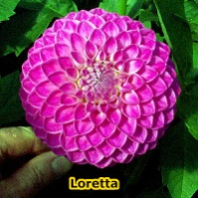 |  | LORETTA  M FD L |  | 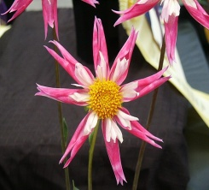 | LORONA DAWN NO PR W
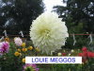 |  | LOUIE MEGGOS A ID W |  | 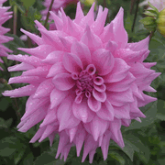 |  | LOVELY LANA  A SC L |  | 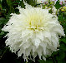 | LULA PATTIE  AA ID W
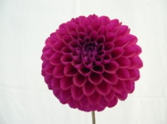 |  | LUPIN CHRIS  BB FD PR |  | 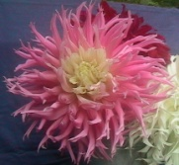 |  | LUPIN PELTIER  ID PK/W |  | 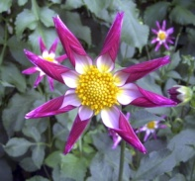 | LUPIN SHEILA  O DP DP/W
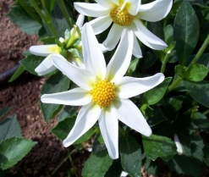 |  | LUPIN TORI MS W |  | 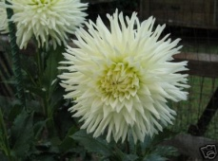 |  | LUTHER  A C W |  | 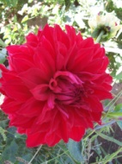 | LYNWOOD  HOUSE  A FD R
 |  | MAARN  BB FD OR |  |  |  | MADISON RED M FD DR
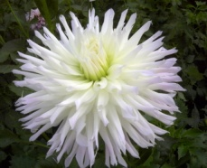 |  | MAGIC MOMENT  B SC WH |  | 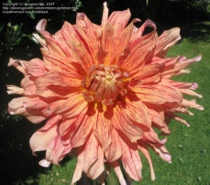 |  | MANIAC  AA SC V O/R |  | 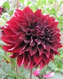 | MANOR JUBILLE BB ID DR
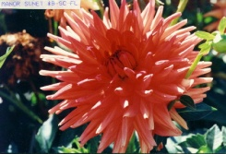 |  | MANOR SUNSET  B SC FL |  | 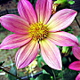 |  | MARCELLA LOUISE S LB LV/YL |  | 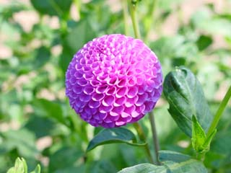 | MARK LOCKWOOD P L
 |  | MARS NO R |  | 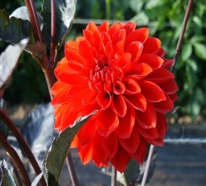 |  | MASTER DAVID’S CHOICE  MB FL |  | 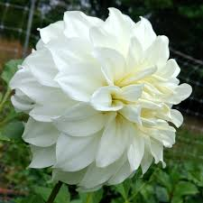 | MAISEY MOONEY  A ID W
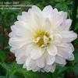 |  | MARGRET ELLEN WL LB WH/LV |  | 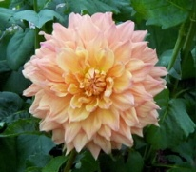 |  | MARGARET DUROSS  AA FD BR |  |  | MARLENE JOY  B LC W/L
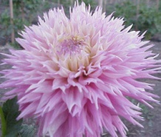 |  | MARVELOUS MEL |  | 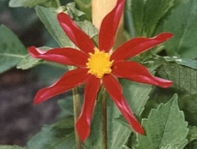 |  | MARIE SCHNUGG  O R |  | 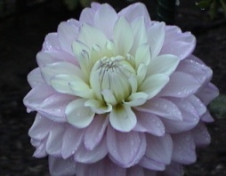 | MARRY ME B ID LB PK/W
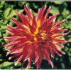 |  | MARTA  A ID R/Y |  | 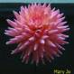 |  | MARY JO  M SC PK
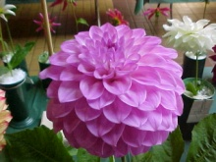 |  | MARY  B FD LB L/W |  | 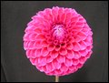 |  | MARY’S JOMANDA  BA DP |  | 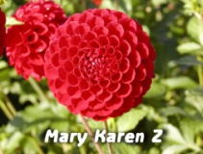 | MARY KAREN Z.  MB DR
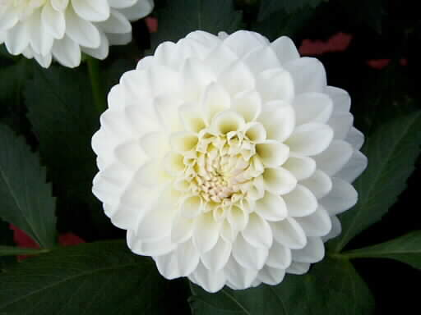 |  | MARY  HAMMET  M FD W |  | 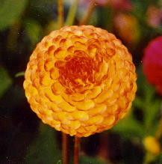 |  | MASTER DAVID  MB FL |  | 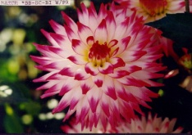 | MATCH  BB SC BI W/PR
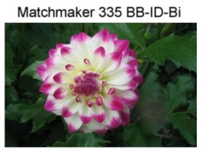 |  | MATCHMAKER  BB ID BI W/PR |  | 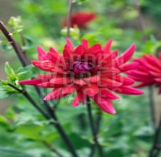 |  | MATHEW ALLEN M SC R |  | 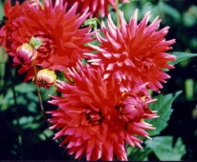 | MATILDA HUSTON  BB SC R
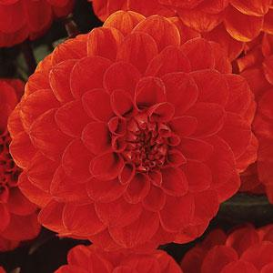 |  | MELODY BOLERO  FD O |  | 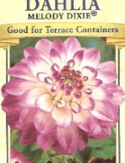 |  | MELODIE DIXIE  BORDER  M FD LB /PK |  | 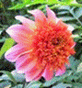 | MEXICO AN L
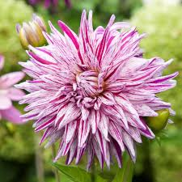 |  | MICK’S PEPPERMINT  A SC V W/R |  | 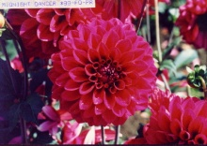 |  | MIDNIGHT  DANCER  BB FD PR |  | 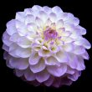 | MIDNIGHT MOON  BB FD LB L/W
 |  |  |  |  |  | MIDNIGHT STAR O DR |  | 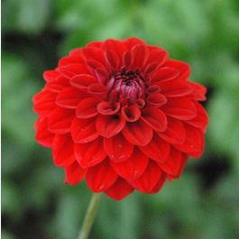 | MILO FD M DR
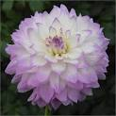 |  | MIKAYLA MIRANDA B ID LB WH/LV |  | 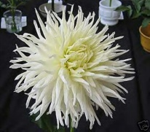 |  | MINERVA MAGIC  B LC W |  | 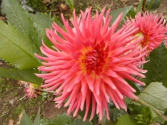 | MINERVA SUNRISE  B IC DB R/Y
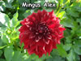 |  | MINGUS ALEX  B ID DR |  | 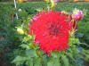 |  | MINGUS  ERIK  BB LC DR |  | 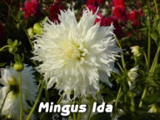 | MINGUS  IDA  A LC W
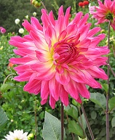 |  | MINGUS  JULIE M.  A C LB P/W |  | 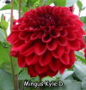 |  | MINGUS KYLE D BB FD R |  | 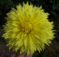 | MINGUS LUCIO F BB LC Y
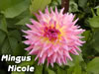 |  | MINGUS NICHOLE  A ID BL PK/Y |  | 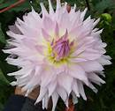 |  | MINGUS  PHILIP II  A SC LB L/W |  | 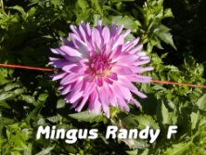 | MINGUS  RANDY F.  A SC LB W/L
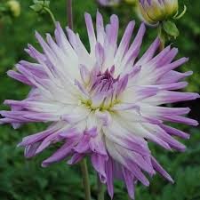 |  | MINGUS RANDY  A SC LB W/L |  |  |  |  |  | 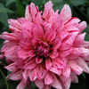 | MINGUS TONI BB ID V DP/DR
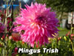 |  | MINGUS TRISH |  | 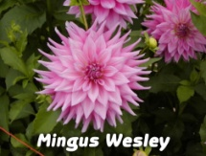 |  | MINGUS WESLEY  A SC LB PK/Y |  | 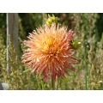 | MISH MASH  B LC LB R/Y
 |  |  |  |  |  |  |  | 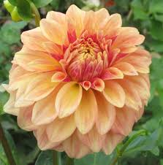 | MISS AMARA BB FD LB Y/PK
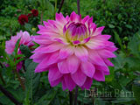 |  | MISS DELILAH  B FD PK/W |  | 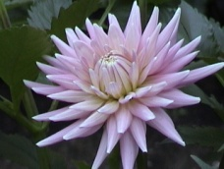 |  | MISS ROSE FLETCHER  BB SC PK |  | 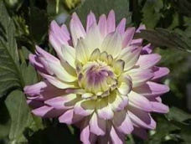 | MISS TEAGAN  BB SC LB PK/W
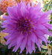 |  | MISTER SANDMAN  B LC Y |  | 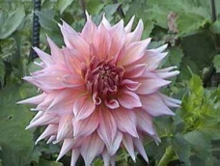 |  | MOM AND DAD AA SC LB Y/PK |  | 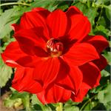 | MOLLY ANN B WL R
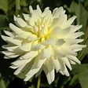 |  | MOONSTRUCK M ID YL |  | 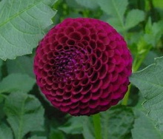 |  | MOOR PLACE  P DR
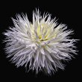 |  | MORGANSTER  B LC W |  | 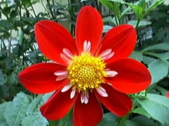 |  | MR. JONES  CO DR r/w |  | 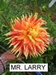 | MR. LARRY AA SC FL
 |  |  |  |  |  |  |  | 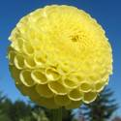 | MRS BLACK  P Y
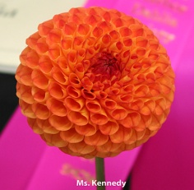 |  | MS KENNEDY  MB OR |  |  |  | MS PRISSY ST DR |  | 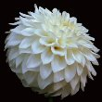 | MULLOY’S MOMENT  BB FD WH
C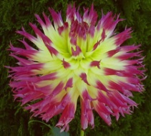 |  | MY BEVERLY  BB LC LB DP/Y |  | 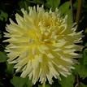 |  | MY LITTLE SUNSHINE BB SC YL |  | 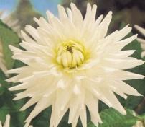 | MY LOVE
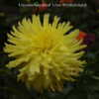 |  | MY LYNDA B C YL |  | 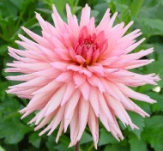 |  | MY ROBYNN  BB IC DPK |  |  | MYSTIC ILLUSION
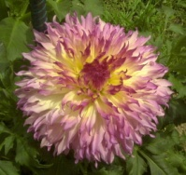 |  | MYRTLE’S FOLLY  B LC DB PR/OR |  | 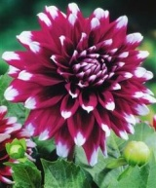 |  | MYSTERY DAY  B FD BI PR/W |  | 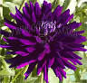 | NADINE JESSIE BB SC PR
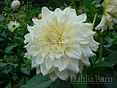 |  | NANKYOKO AA FD W |  | 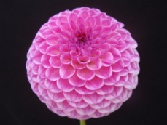 |  | NARROWS PAM BA L |  | 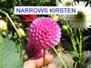 | NARROWS KRISTEN BA DP
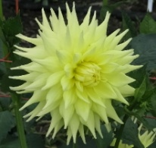 |  | NARROWS TRICIA  B SC Y |  | 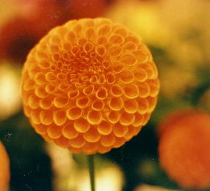 |  | NATALIE G.  BA O |  | 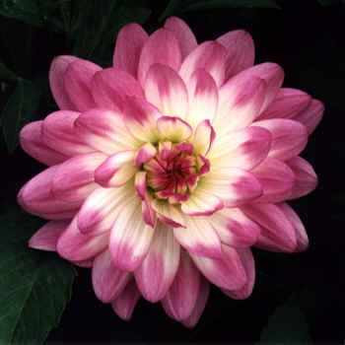 | NEPOS  WL LB W/L
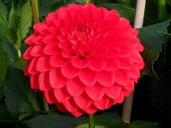 |  | NELLIE J.  BB FD DR |  | 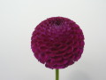 |  | NELLIE’S ROSE P PR |  | 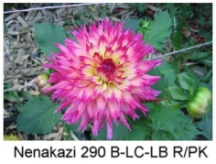 | NENEKAZI  B LC DB DP/Y
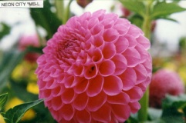 |  | NEON CITY  MB L |  |  |  | NEON SPLENDER B ID FL |  | 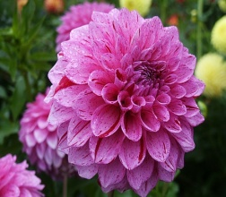 | NEWAUKUM JULIE BB FD V LV/DR
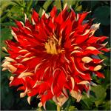 |  | NICK SR. AA ID R (BR) |  | 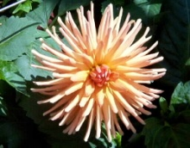 |  | NICOLE C.  M C OR |  | 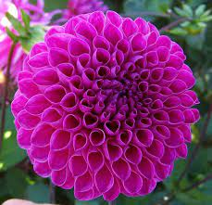 | NIJINSKY MB FD LV
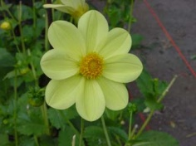 |  | NORMANDY LEMON DROP  S Y |  |  |  |  |  | 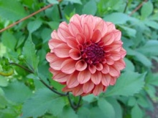 | NORMANDY  MIKEY  M DB BR/DR
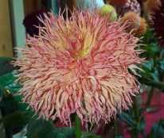 |  | NORMANDY SPARKLER  B LC LB O/Y |  | 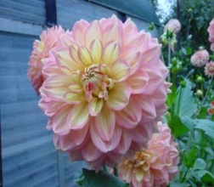 |  | NORMANDY SWEET LUCY B FD Y/O |  | 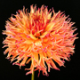 | NORMANDY ORANGE FLUFF B LC DB OR/R
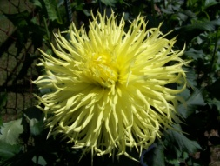 |  | NORTHLAKE HERATIGE B LC Y |  | 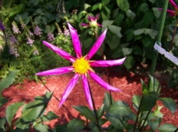 |  | NORTHWEST BRIAN D.  O P |  | 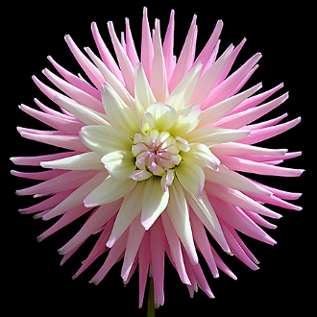 | NTAC PATRICIA B C LB PK/WH
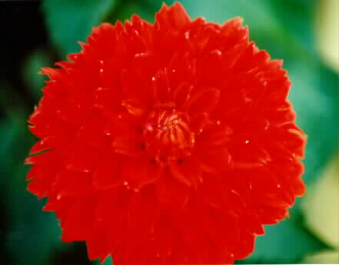 |  | ORANGE CUSHION  M ID O |  | 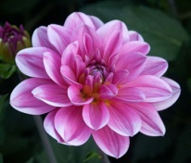 |  | ONESTA  WL DP |  | 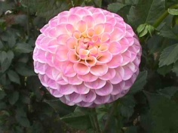 | ODDYSEY  MB LB L/W
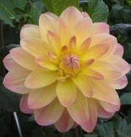 |  | ORETI INNOCENCE  WL LB Y/PK |  | 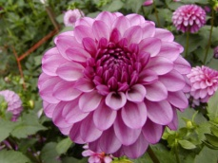 |  | ORETI LIZ  M FD PR |  | 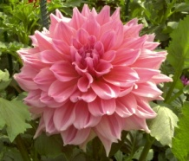 | OTTO’S THRILL  AA ID PK
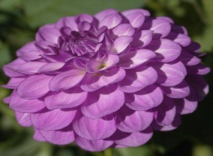 |  | OUTTA DA BLUE M FD L |  | 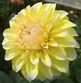 |  | OVA-JO BB FD BI YL/WH |  | 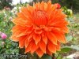 | PARKLAND GLORY A ID BR
 |  | PARKLAND RAVE BB IC LV |  | 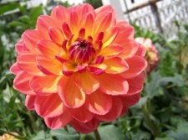 |  | PAM HOWDEN  WL OR |  | 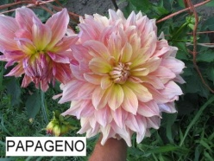 | PAPAGENO  AA ID LB  PK/Y
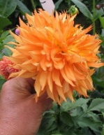 |  | PAPA’S BENJI  B LC OR |  | 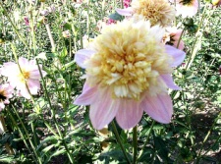 |  | PARKLAND PRINCESS  AN LB PK/Y |  | 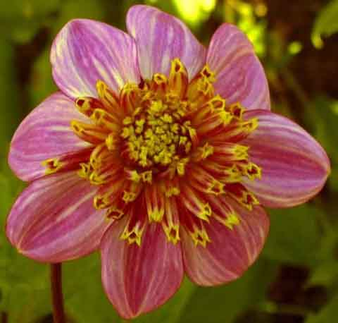 | PARKLAND PRINCE  AN LB L/P/l/y
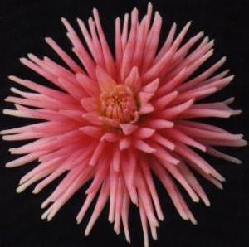 |  | PARK PRINCESS  M C DPK |  | 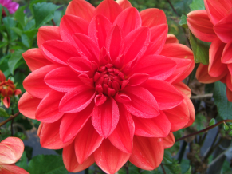 |  | PATRICA ANN’S  SUNSET  WL FLAME |  | 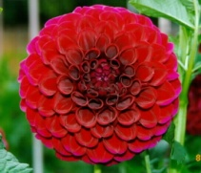 | PAUL SMITH  BA DR
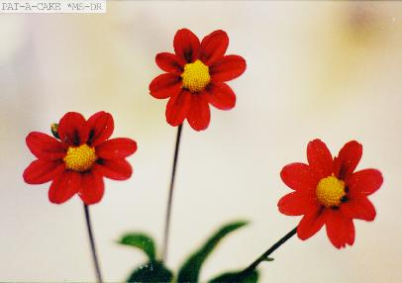 |  | PAT-A-CAKE  MS DR
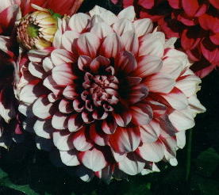 |  | PATCHES  B FD BI |  | 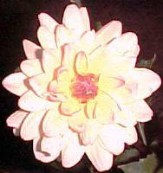 |  | PAT FEARY  WL LB PK/Y |  | 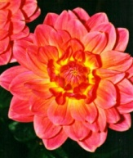 | PATTY  WL DP
 |  |  |  | 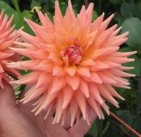 |  | PEACH DELIGHT  B SC PK |  | 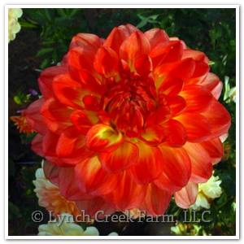 | PEACHES  B FD PK/O
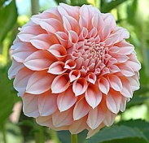 |  | PEACHES N CREAM  M FD B O/W |  | 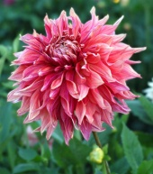 |  | PENHILL DARK MONARCH  AA ID DB PR/YL |  | 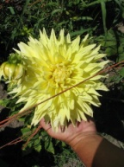 | PENHILL MOONRISE  AA ID Y
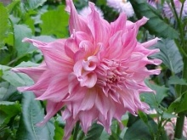 |  | PENHILL WATERMELON  AA ID LB |  | 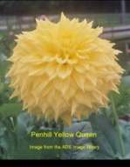 |  | PENHILL YELLOW QUEEN  A ID Y |  | 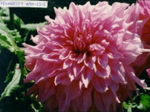 | PENNSGIFT  AA ID L
 |  |  |  | 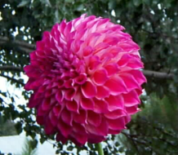 |  | PHOENIX  B FD PR |  |  | PINEAPPLE LOLLIPOP  M FD Y
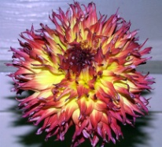 |  | PINELAND’S PAM  B LC FL |  | 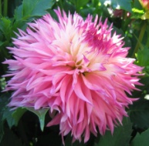 |  | PINELAND’S PRINCESS  B LC LB L/W
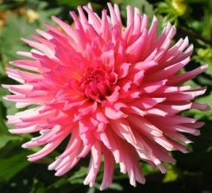 |  | PINK BUBBLEGUM BB IC DP |  | 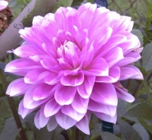 |  | PINK GINGHAM  WL PK/W |  | 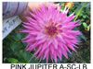 | PINK JUPITER A SC LB PK/DP
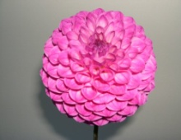 |  | PINK  ROBIN HOOD  BA DP |  | 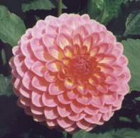 |  | PINK SUFFUSION  BB FD LB PK/Y |  | 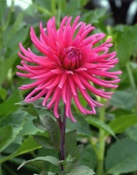 | PINOT NOIR  M C DP
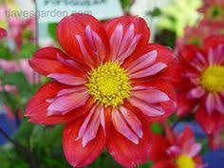 |  | PIPSQUEAK CO DP/PK |  | 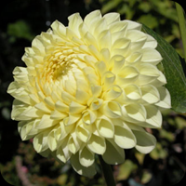 |  | POLYVENTON SUPREME  BA Y |  | 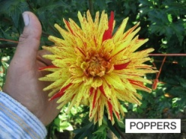 | POPPERS  BB SC V Y/R
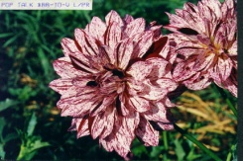 |  | POP TALK  BB ID V L/PR |  | 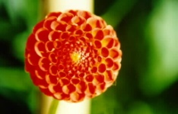 |  | POPPET  P OR |  | 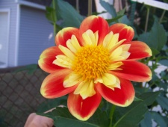 | POOH  CO BI RD/Y/y
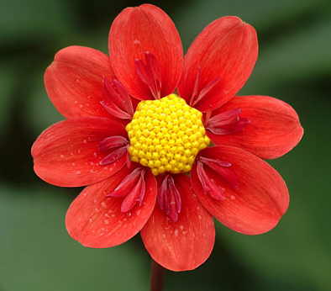 |  | PROCHE AMI  CO M R |  | 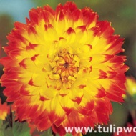 |  | PROCYON  BB ID FL |  | 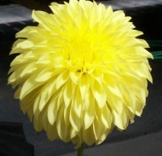 | PRIMROSE PET  ST Y
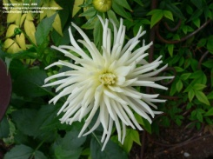 |  | PRINCE CHARMING  BB C W |  | 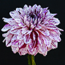 |  | PRINCE VALIANT BB FD V W/DR |  | 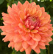 | PUMPKIN SPICE B LC O
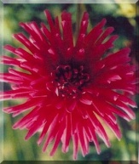 |  | PURPLE GEM  BB IC PR |  | 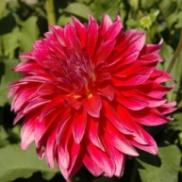 |  | RASPBERRY PUNCH  ST DP |  | 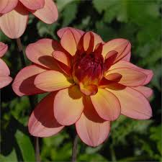 | RAWHIDE MWL LB RD/YL
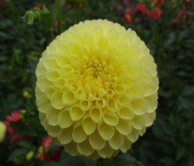 |  | RC LAURA MB Y |  | 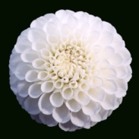 |  | RJR  BB FD W |  |  | REAL GOLD P BR
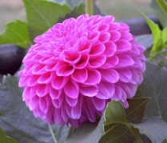 |  | REBECCA LYNN  M FD PK |  | 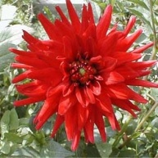 |  | RED PYGMY  M SC R |  | 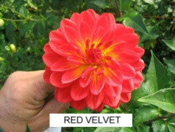 | RED VELVET  WL R
 |  | REJMAN’S MIDNIGHT POM  P DR |  | 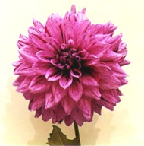 |  | REJMAN’S JOSEPH  BB FD V DP/R |  | 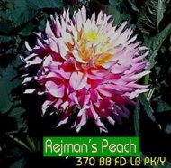 | REJMAN’S PEACH  BB FD LB P/Y
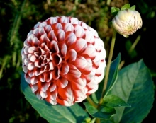 |  | REJMAN’S POLISH KID  M FD BI R/W |  |  |  | REJMAN’S RUSTY RED M DR/BR |  | 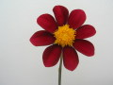 | REMBRANT MS DR
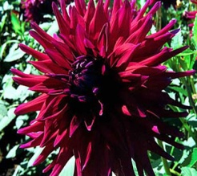 |  | REV. P. HOLIAN AA SC PR |  |  |  | REVELATION  AA ID OR |  | 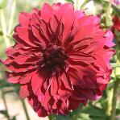 | RICHARD RODGERS AA FD DR
 |  | RICHTER B SC O |  |  |  | RINSHO  B ID BI L/W |  | 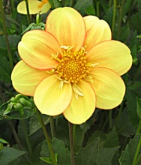 | RIO FINO  CO LB Y/R
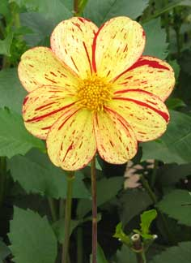 |  | RIO FIESTA  MS V R/Y |  | 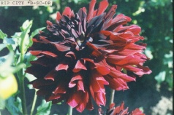 |  | RIP CITY  B SC DR |  |  | RIVAL MS R
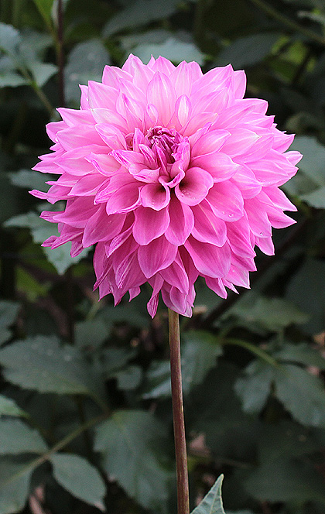 |  | ROBANN BUBBLE GUM BB LAC LB DP/WH |  | 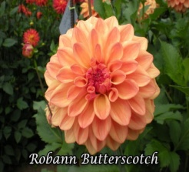 |  | ROBANN BUTTER SCOTCH BB ID LB DP/Y |  | 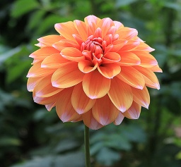 | ROBANN CREAMSICLE BB ID BI OR/PK
 |  | ROBANN REGAL M FD L |  | 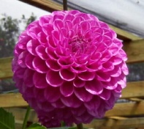 |  | ROBANN ROYAL  MB L |  | 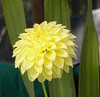 | ROBANN SUNSPOT M FD Y
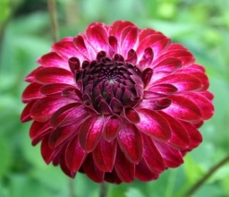 |  | ROBERT TOO M FD DB W/PR |  | 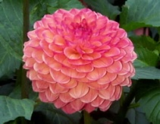 |  | ROBIN HOOD  BA DB O/PK
 |  |  |  | 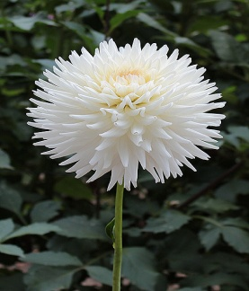 |  | ROCK RUN ELVA BB SC WH |  | 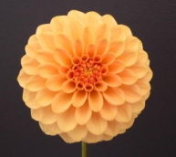 | ROCK RUN EMILY  M FD BR
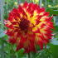 |  | ROCK RUN  JAMES  B ID FL |  | 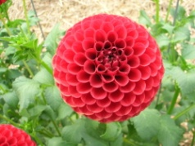 |  | ROCK RUN KAITLIN  MB DR |  | 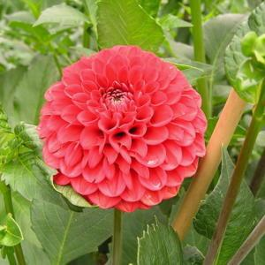 | ROCK RUN MEA M FD R
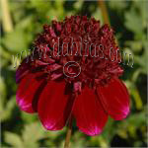 |  | ROCK STAR AN DR |  | 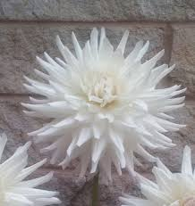 |  | ROQUE STARBURST AA SC W |  | 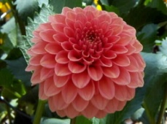 | ROSE TOSCANO  M FD BR
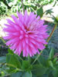 |  | RUSKIN ANDREA B SC L LV6/LV9 |  | 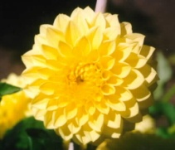 |  | RUSKIN DIANE  BB FD Y |  | 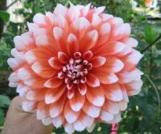 | REJMAN’S CANDY CORN
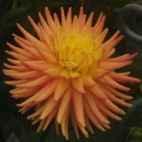 |  | RUSKIN MYRA  BB SC LB |  | 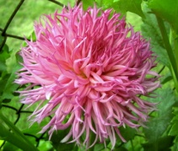 |  | RUBY VIOLA  B LC DP |  | 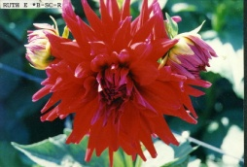 | RUTH E.  B SC R
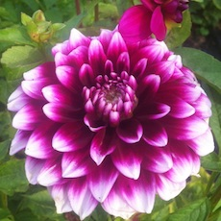 |  | RYAN C B FD BI PR/WH |  | 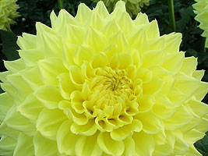 |  | RYCROFT ALEX  B ID Y |  |  | RYCROFT CLUB  BA Y
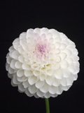 |  | RYCROFT DAVES CHOICE M FD W |  | 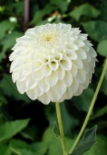 |  | RYCROFT JAN  M FD W |  | 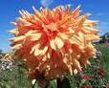 | SAM HUSTON  AA ID BR
 |  | SB’S FIESTA BB FD V Y/R |  | 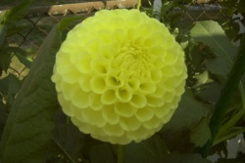 |  | SB’S SUNNY  MB Y |  | 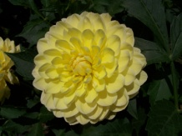 | SANDIA JOY  WL Y
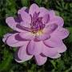 |  | SANDIA SHOMEI WL L |  | 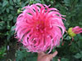 |  | SARAH MAE A IC DP |  | 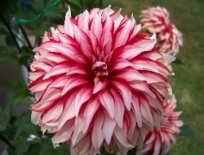 | SANTA CLAUS  BB ID BI R/W
 |  | SAYONARA BB ID PK |  | 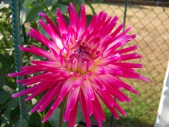 |  | SCARBOROUGH  BRILLIANT  BB IC DB R/PK
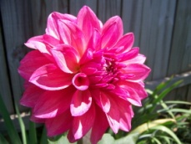 |  | SCAURS WINTON  B FD DP |  | 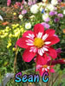 |  | SEAN C CO PR |  | 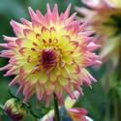 | SEA-Heldao A SC LB Y/PK
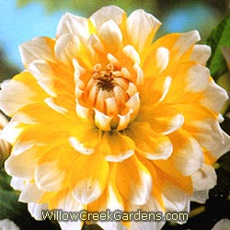 |  | SEATTLE  B FD BI Y/W |  | 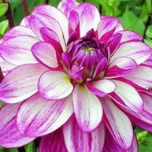 |  | SEDUCTION BB ID L |  | 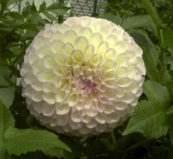 | SENIOR BALL  BA L/WH
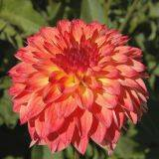 |  | SEPTEMBER MORN  BB FD Y/OR |  | 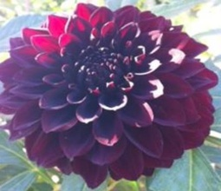 |  | SHADOW CAT M FD DR |  |  | SHARKY BA BI PR/WH
 |  | SHEA’S RAINBOW  M C V PK/Y |  | 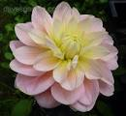 |  | SHEER HEAVEN BB FD LB PK/YL
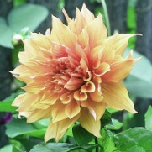 |  | SHERWOOD’S  PEACH  AA ID BR |  | 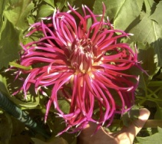 |  | SHINKYOKU  NX PR |  | 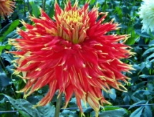 | SHOW N TELL  AA LC DB R/Y
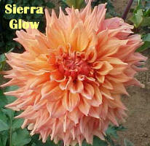 |  | SIERRA GLOW  A ID BR |  | 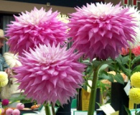 |  | SIR ALF RAMSEY  AA ID LB L/W |  | 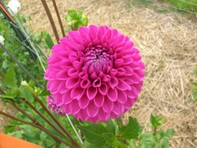 | SIR RICHARD  MB DP
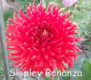 |  | SKIPLEY BONANZA B IC R |  | 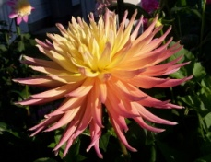 |  | SKIPLEY GRANDE  A SC LB Y/DPK |  | 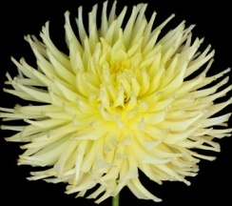 | SKIPLEY MELLO YELLO B IC Y
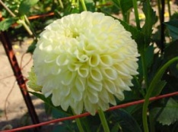 |  | SKIPLEY MOONGLOW  BA Y |  | 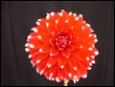 |  | SKIPLEY SPOT  BB FD BI R/W
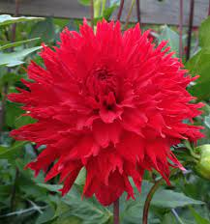 |  | SKYWALKER BB FD RD |  | 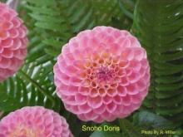 |  | SNOHO DORIS  BA DB R/BR |  | 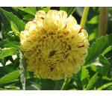 | SNOHO FRECKLES MB V Y/R
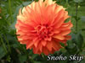 |  | SNOHO SKIP  ST O |  | 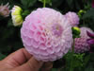 |  | SNOHO SONIA BA L |  |  | SNOHO TAMMIE  BA PK
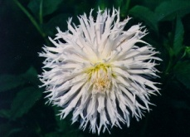 |  | (SNOHO)  BLIZZARD  B LC W |  | 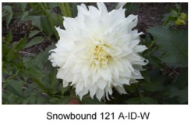 |  | SNOW BOUND  A ID W |  | 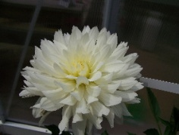 | SNOWFLAKE  WL W
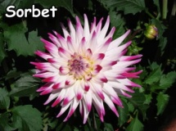 |  | SORBET  B SC DB DR/W |  | 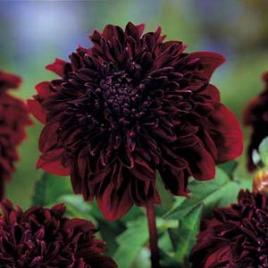 |  | SOULMAN  AN DR |  | 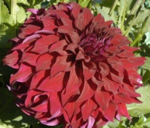 | SPARTACUS  A ID DR
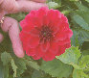 |  | SPITFIRE M FD R |  | 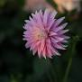 |  | STARRING ST PK |  | 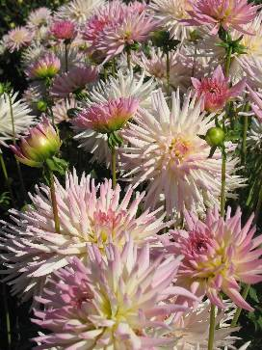 | STAR’S LADY BORDER SC LB PK/W
 |  | STELLA R.  BB FD DP |  | 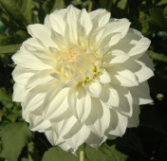 |  | STERLING  SILVER  B FD W |  | 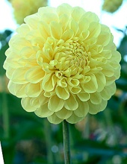 | STEPHENIE  BA Y
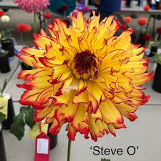 |  | STEVE O NX FL YL/RD |  |  |  | STILLWATER BRILLIANT B SC DB PR/PR/WH |  | 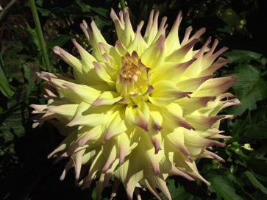 | STILLWATER KRISTA BB ID LB Y/PK
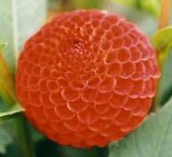 |  | STONELEIGH JOYCE  P R |  |  |  | STRAWBERRY ICE A FD PK |  | 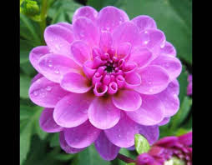 | SUITZUS JULIE WL L
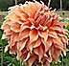 |  | SUMMER RAIN B ID BR |  | 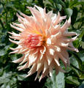 |  | SURPRISE  A SC PK |  | 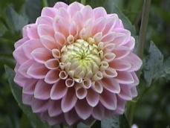 | SUGARTOWN SUNRISE M FD LB LV/YL
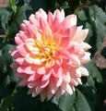 |  | SUMMER’S END  WL LB DP/Y |  | 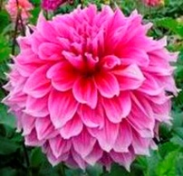 |  | SURVIVOR  AA FD LAV |  | 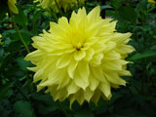 | SUNNY  A ID Y
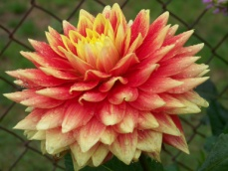 |  | SWAN’S SUNSET  A ID DB R/OR |  | 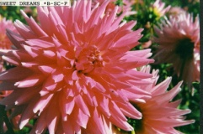 |  | SWEET DREAMS  B SC PK |  | 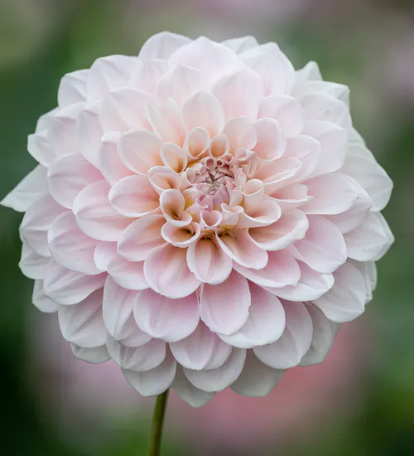 | SWEET NATALIE FD BB PK
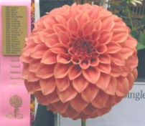 |  | SYLVIA CRAIG HUNTER  B FD O |  | 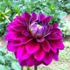 |  | TABOO BB FD PR |  | 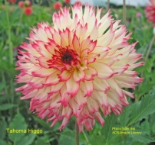 | TAHOMA HIGGO  B LC LB Y/DR
 |  | TAHOMA ROYALTY  M FD PR |  | 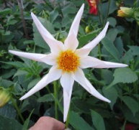 |  | TAHOMA STAR  O W |  | 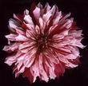 | TAHEIYO  A ID V PR/W
 |  | TAHITI SUNRISE BB SC DB Y/R |  | 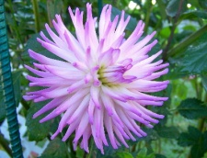 |  | TARATAHI LILAC  BB IC LB L/W |  | 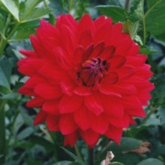 | TARATAHI  RUBY  WL R
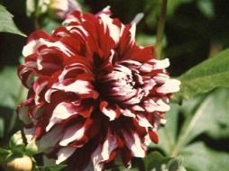 |  | TARTAN  B ID BI DR/W |  | 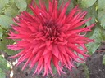 |  | TAUM SAUK AA SC DR |  | 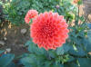 | TEMPEST BB FD DP
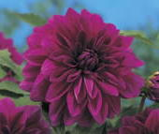 |  | THE BARON  BB FD PR |  | 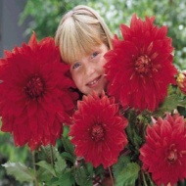 |  | THE BIG WOW  AA FD R |  | 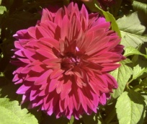 | THOMAS A. EDISON  B FD PR
 |  |  |  | 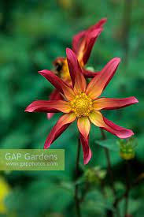 |  | TIFFANY LYNN O DB OR RD |  | 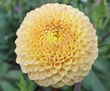 | TINY P BR
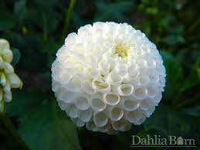 |  | TINY TREASURE P WH |  | 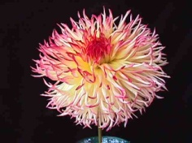 |  | TIOGA AUTUMN  B LC LB Y/DP |  | 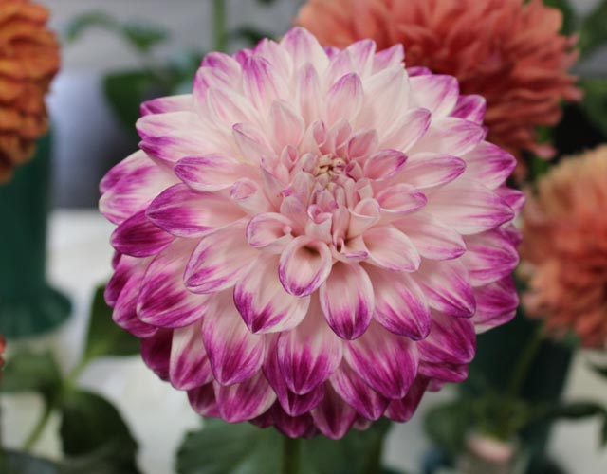 | TLC KISS BB FD DB DR/WH
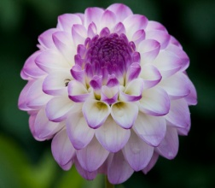 |  | TREBY DAINTY MB LB W/P |  | 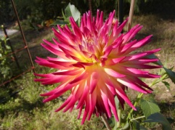 |  | TRELYN RHIANNON  B C DB DP/Y |  | 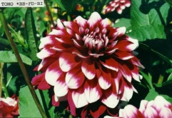 | TOMO  BB FD BI PR/W
 |  |  |  | 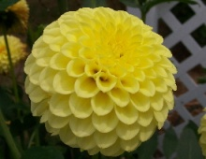 |  | TONYA  MB Y |  | 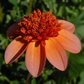 | TOTALLY TANGERINE AN OR
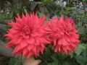 |  | TOTENKO AA SC R |  | 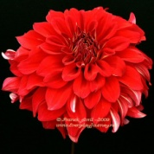 |  | TOO SEXY BB FD R |  | 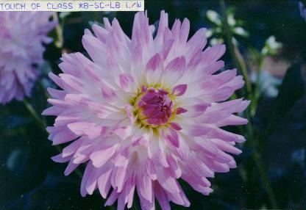 | TOUCH OF CLASS  B SC LB L/W
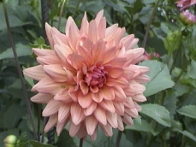 |  | TOUCHE  BB SC PK |  | 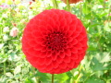 |  | TOY BOY  M FD R |  | 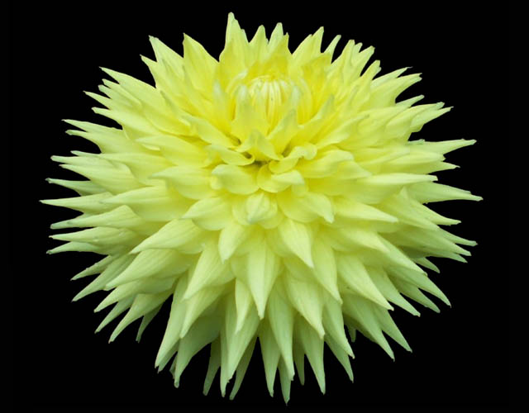 | TROOPER DAN A SC Y
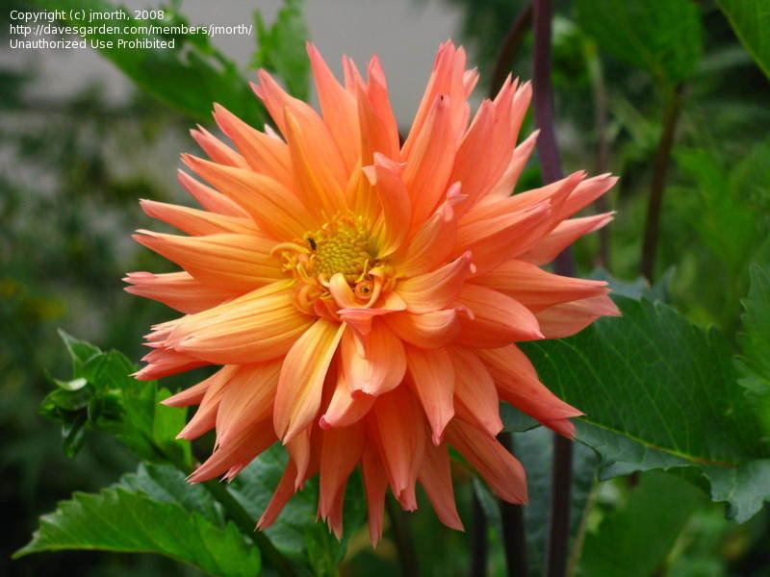 |  | TROPIC SUNDAY BB SC FL PK / RD |  | 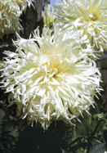 |  | TSUKI YORI NO SHISHA B LC W |  | 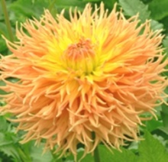 | TWILIGHT TIME  B LC O
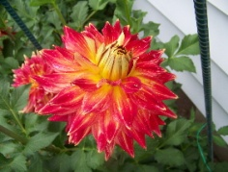 |  | TYLER JAMES  A ID FL R/Y |  |  |  |  |  | 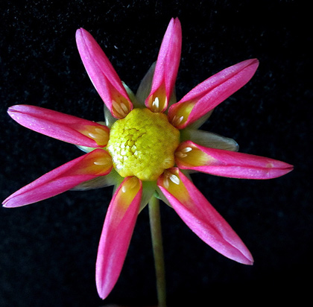 | U2 ANIA MNO DP
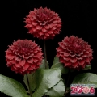 |  | UKRAINE FREE B ID DR |  |  |  | UMPQUA  SURPRISE |  | 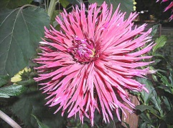 | URCHIN  BB LC DR
 |  |  |  | 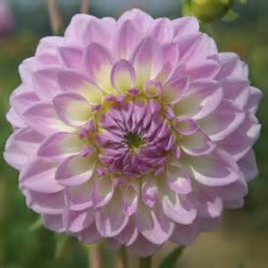 |  | VALENTINE LIL  BB FD LB  LV/WH |  | 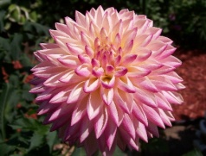 | VALLEY PORCUPINE  NX LB
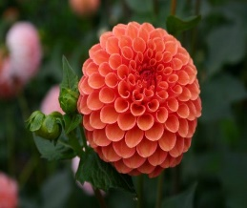 |  | VALLY RUST BUCKET MB BR
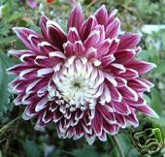 |  | VANCOUVER  NX PR |  | 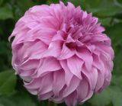 |  | VASSIO MEGGOS  A FD L |  | 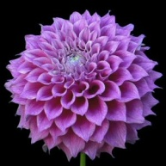 | VERA’S ELMA  A FD L
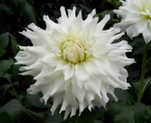 |  | VERDA  A SC W |  | 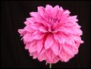 |  | VERNON ROSE  BB FD V PK/DR |  | 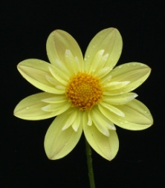 | VERRONE’S CITRINE CO Y
 |  |  |  | 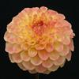 |  | VERRONE’S DANA BB FD LB Y/R |  | 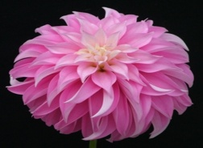 | VERRONE’S DF ST PK
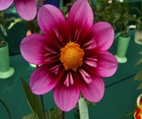 |  | VERRONE’S JACKIE V CO DB DP/LV LB W/Y |  | 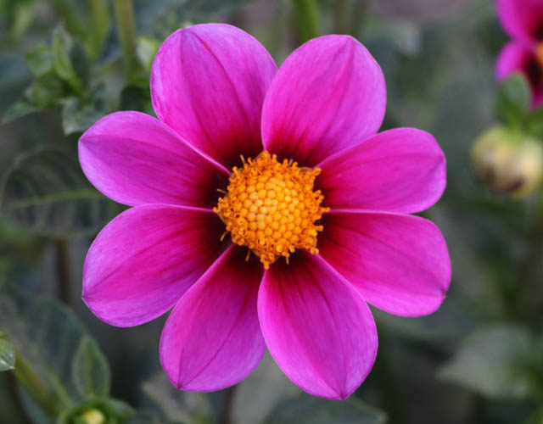 |  | VERRONE’S LANCE BROWN S PR |  | 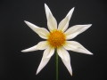 | VERRON’S MOURNING STAR OT W
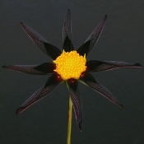 |  | VERRONE’S OBSIDIAN O PR |  | 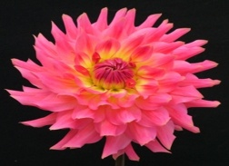 |  | VERRONE’S PATSY BB ID DPK
 |  |  |  | 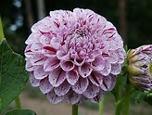 |  | VERRONE’S STEVEN D M FD V WH/PR |  | 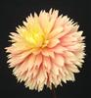 | VERRONE’S SUNBURST BB LC LB PK/Y
 |  | VERRONE’S TABBI S R/W |  | 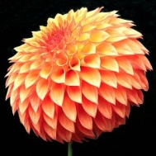 |  | VERRONE”S SANDRA J. BB FD O
 |  |  |  | 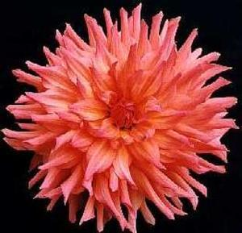 |  | VIOLA R. |  | 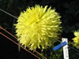 | VISTA LINDSEY BB LC Y
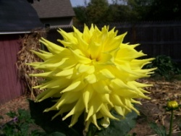 |  | VICKI  A SC Y |  | 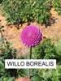 |  | WILLO BOREALIS P L |  | 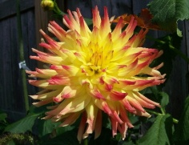 | VONALLEE  B SC FL
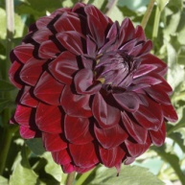 |  | VOODOO  BB FD R |  | 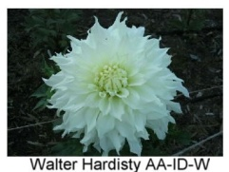 |  | WALTER HARDISTY  AA ID W |  | 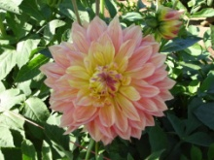 | WANDA’S AURORA  AA ID  LB PK/Y
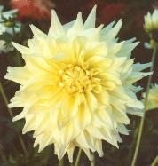 |  | WANDA’S MOONLIGT  AA ID Y |  | 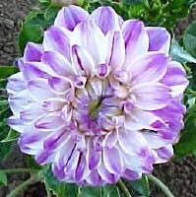 |  | WATERCOLORS M FD L |  | 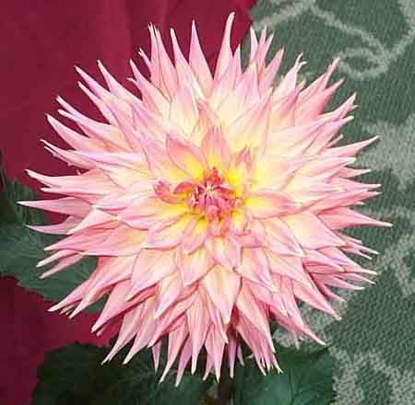 | WENDY MINER  B SC DB P/Y
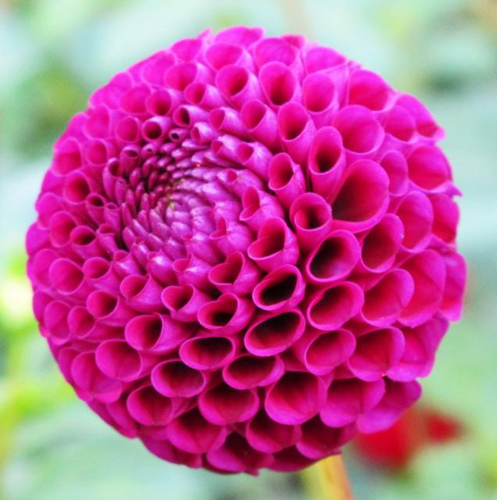 |  | WENDY’S PLACE P PR |  | 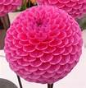 |  | WESTERTON FOLLY BA PK |  | 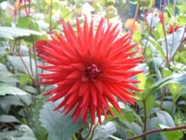 | WESTON PIRATE  M C DR
West Michigan Dahlia Society  Look us up at:  http://www.  midwestdahliaconference.org/WMDS |  |  |  | 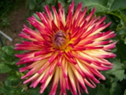 |  | WESTON SPANISH DANCER  M C FL |  | 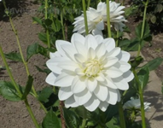 | WHITE BALLET WL W
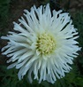 |  | WHITE LIGHTENING M IC W |  | 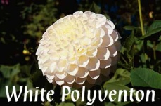 |  | WHITE POLYVENTON  SUPREME  BA |  |  | WHITE RABBIT BA V DR/WH
 |  |  |  | 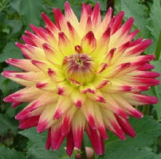 |  | WILDCAT M SC DB DR/Y
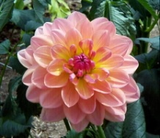 |  | WILDWOOD  MARIE  WL DPK |  | 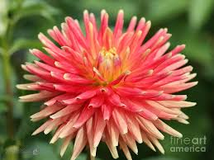 | WILLIE OF ORANGE BB C OR |  |  | 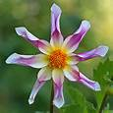 | WILLIE WILLIE O LB P/PR/DR/W
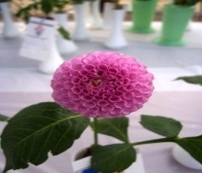 |  | WILLO BOREALIS P L |  | 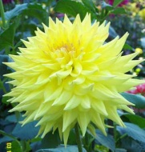 |  | WINDHAVEN BLUSH  A SC Y |  | 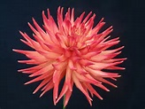 | WINDHAVEN FIRELIGHT BB C FL RD/YL
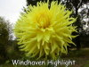 |  | WINDHANEN HIGHLIGHT B IC Y |  | 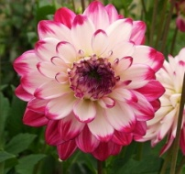 |  | WINE & ROSES  WL W/R
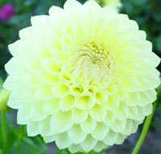 |  | WINHOLME DIANE  BB FD Y |  | 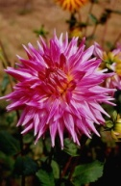 |  | WINKIE CARNIVAL  B FD LB L/W |  | 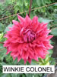 | WINKIE CORONEL AA ID R
 |  |  |  |  |  |  |  | 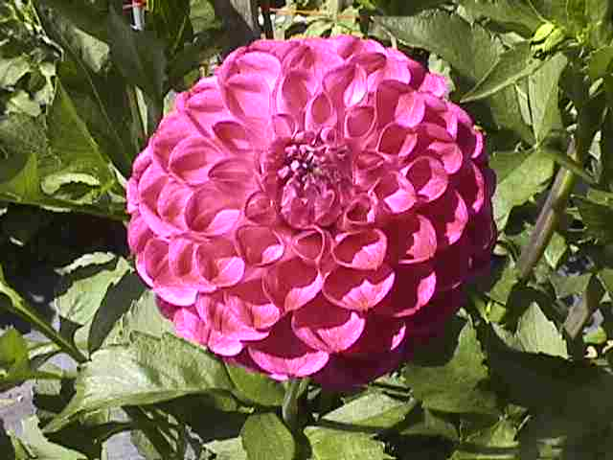 | WOODLAND’S  DUFUS  MB PR

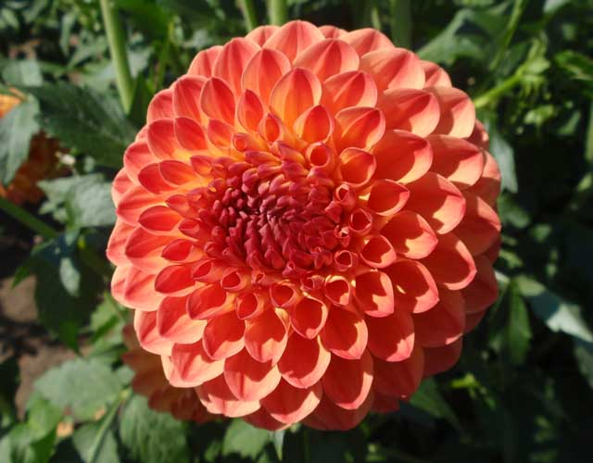 | WOODLAND’S TACO TIME BB FD LB Y/O |  | 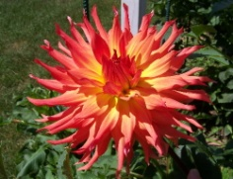 |  | WOODLAND S  WILDTHING  B SC O |  |  | RC LAURA MB Y
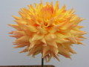 | WYN’S ASPEN GLOW AA SC LB BR/Y |  | 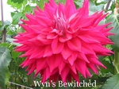 |  | WYN’S BEWITCHED A SC PR |  | 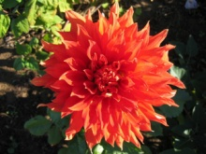 | WYN’S CINNABAR  AA SC R
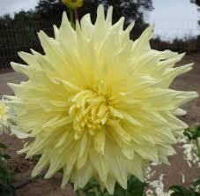 | WYN’S CONQUISTADOR AA ID Y |  | 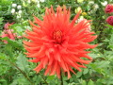 |  | WYN’S DELTA FRANK AA SC OR |  | 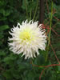 | WYN’S FARMER JOHN AA ID LB W/Y/L
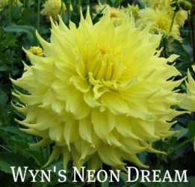 | WYN’S NEON DREAM AA ID Y |  | 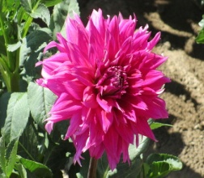 |  | WYN’S PURE MAGIC A ID LB P/W |  | 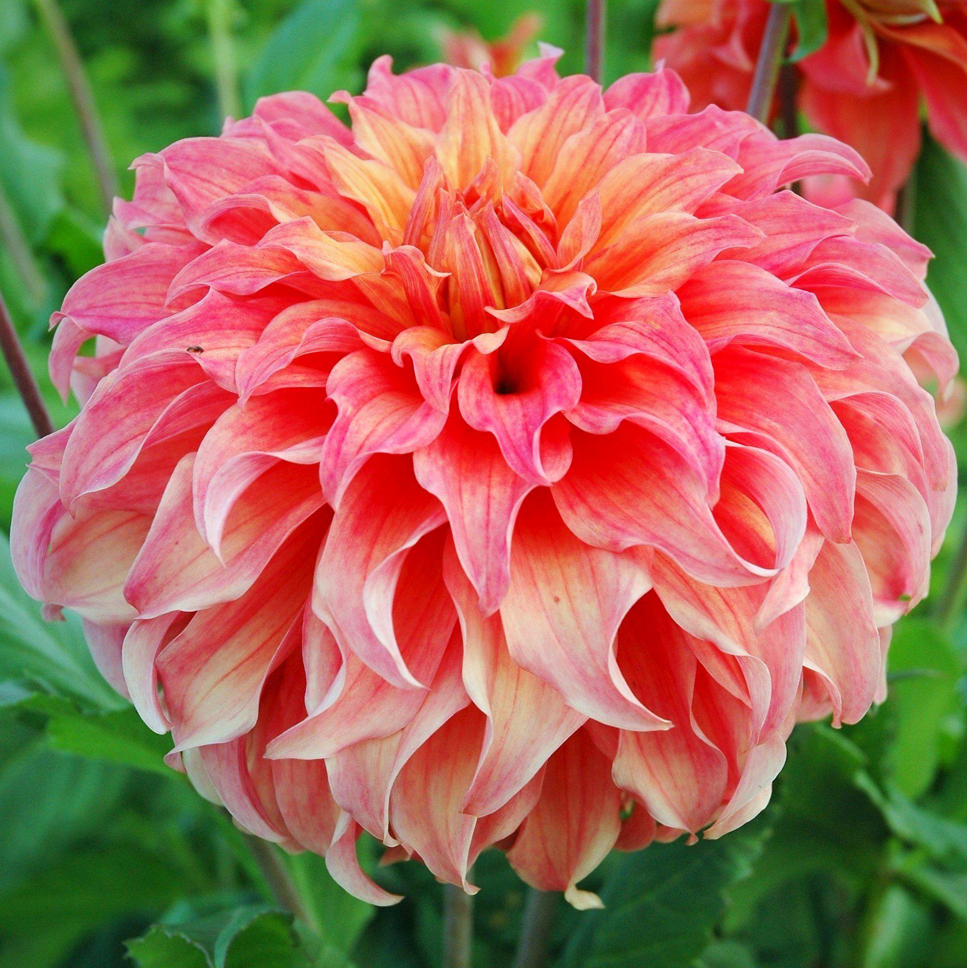 | WYN’S MOONLIGHT SONATA B ID LB PK/YL
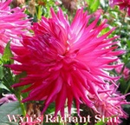 | WYN’S RADIANT STAR A IC DB PR/WH |  | 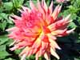 |  | WYN’S KING SALMON AA SC DP |  | 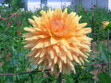 | WYN’S SENSATION A SC BR
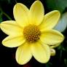 | YELLOW BABY P YL |  | 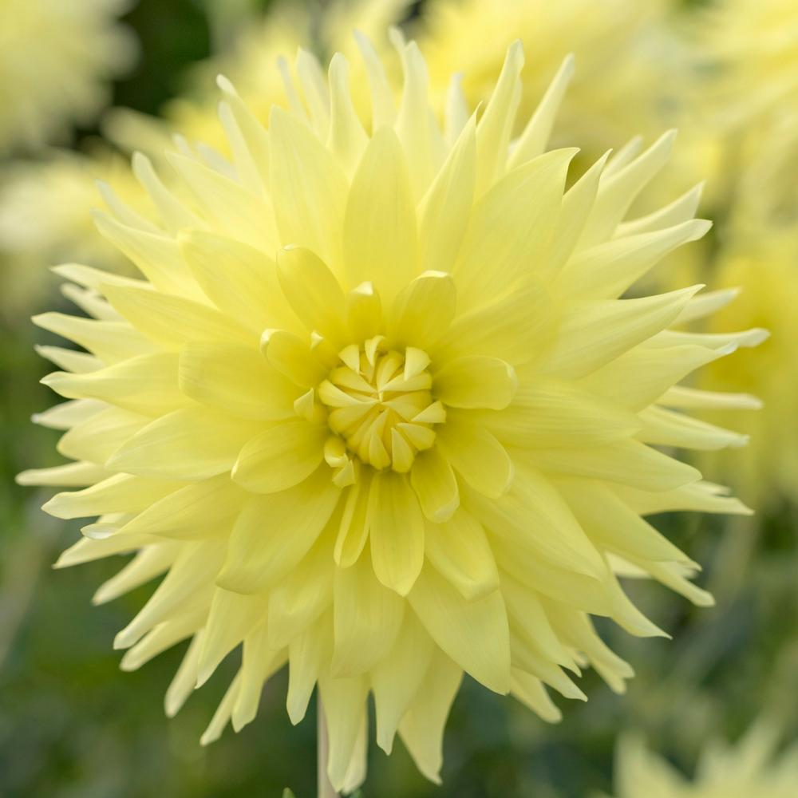 |  | YELLOW PASSION A SC YL |  | 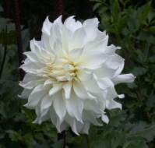 | YUUKYU  B ID W
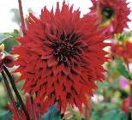 | ZAPF’S DESERT STORM  B SC DR |  | 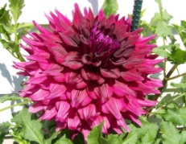 | ZORRO  AA ID DR |  |  |  | ZAKARY ROBERT BB FD BI R W

